 A LEVEL COMPUTER SCIENCE NEA

Using Neural Networks to Identify Mushrooms

By Benjamin Banks

Contents

ANALYSIS 3

DESIGN 21

Technical Solution 37

Testing 82

Evaluation 83

Bibliography 87

# ANALYSIS

Researching the Problem

My broad goal is to create software for identifying mushrooms. However, since there are so many varieties, I need to know which mushrooms to prioritise identifying. Researching mushroom trends will help me make these decisions.

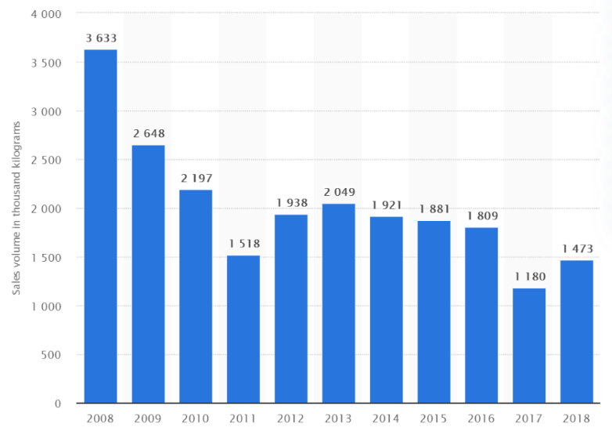 (Wunsch, 2020)

These statistics show an average decline in preserved mushroom and truffle sales in the UK. It is important to realise mushrooms like truffles grow in seasons and are highly dependent on weather. However, because the data was collected over a period of 10 years, there is substantial evidence of fewer sales in truffles and preserved mushrooms. The mushroom market has certainly not declined, thereby suggesting people are preferring to eat fresh mushrooms over dried mushrooms. This implies I should prioritise identifying fresh mushrooms over preserved mushrooms.

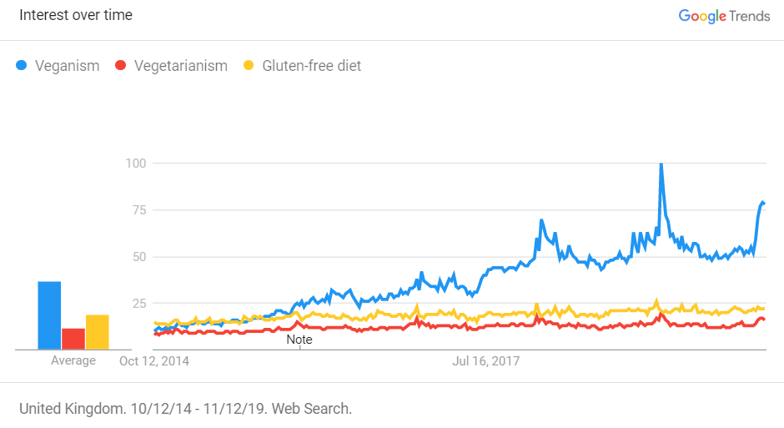 (Statistics | The Vegan Society, 2020)

Compared to Vegetarianism and gluten-free diets, the graph suggests veganism is becoming more popular at a rapid rate. This trend will certainly boost the mushroom market as mushrooms are a common substitute for meat- they are low in fat and packed with vitamins and nutrients. Hence, this data supports me creating my software because more people than ever will be relying on mushrooms for sustenance.

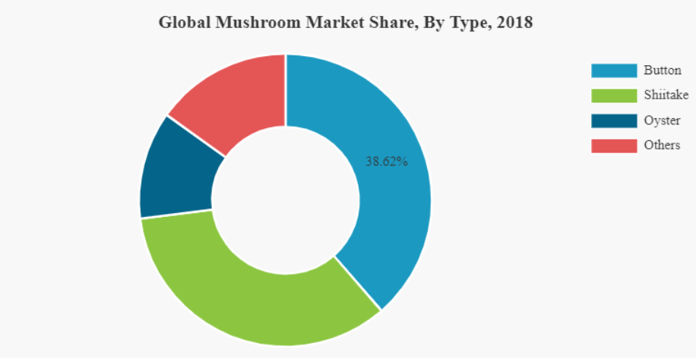 (Mushroom Market Size, Share, Growth - Industry Analysis 2026, 2020)

This pie chart shows the distribution of mushroom varieties in the global market. Clearly oyster, shiitake and button/field mushrooms are the three most common varieties. Therefore, statistically speaking, these mushrooms will have the highest chance of being the mushroom the user is identifying. Hence, I will include these three mushroom varieties in the first edition of my software.

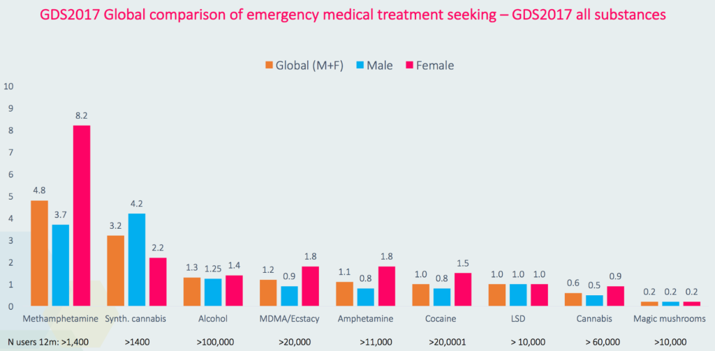 (Solon, 2020)

This graph compares the number of fatalities different drugs induce. Supposedly ‘magic mushrooms’ are the least harmful drug. This implies I should give mushroom varieties under the category of ‘magic mushrooms’ lower priority when coding the software, because of their low risk.

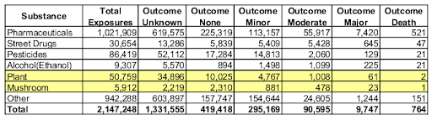 (Joe@EatThePlanet, 2020)

This table records the number of people poisoned by substances in 2010. These results will differ in UK, but they give a general idea of mushrooms as being low risk. However, the total number of exposures to mushrooms is the lowest of all the recorded substances. Hence, it is clear people are careful eating mushrooms they don’t know about. This further supports the creation of my program, as it would improve people’s confidence that they know the mushroom they are picking.

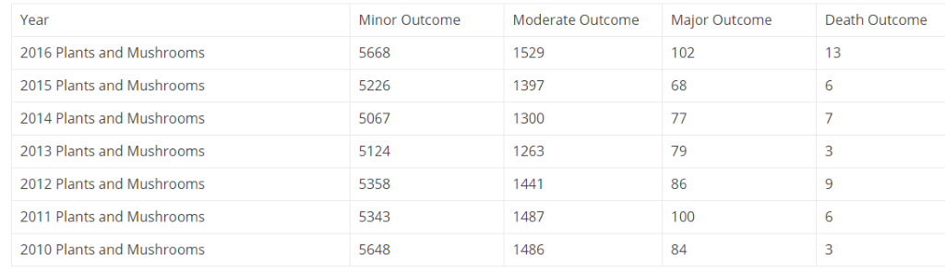 (Joe@EatThePlanet, Foraging Fatality Statistics 2016 - Eat The Planet, 2020)

This table shows the number of people poisoned by plants and mushrooms from 2010 to 2016 in the US. The data could be biased towards plants inducing more harmful poisonings than mushrooms, or visa versa. Therefore, it isn’t ideal but still useful. All four categories – minor outcome, moderate outcome, major outcome and death outcome, their ratio in each year is completely different. Clearly the risk of the poisonings is dependent on what species the victim ingests. Any year could have record numbers of poisonings; therefore, I will make sure to include poisonous mushrooms which cause the most fatalities in my software’s first release.

|  |  |  |
| --- | --- | --- |
| Mushroom | Rarity | Symptoms |
| Death cap | common | Vomiting, diarrhoea, stomach pains followed by full recovery then death by liver or kidney poisoning. |
| Destroying Angel | uncommon | Vomiting, diarrhoea, stomach pains followed by full recovery then death by kidney or liver poisoning. |
| Funeral Bell | common | Vomiting, diarrhoea, stomach pains followed by full recovery then possible death by kidney or liver poisoning. |
| Deadly Webcap | uncommon | Flu like symptoms, headache, vomiting followed by kidney poisoning and possible death. |
| Panther cap | uncommon | Hallucinations, confusions, visual distortions and possibly death |

These are the deadliest mushrooms in the UK. When ingested they can all lead to death but ingesting the death cap or destroying angel means certain death. Including these two deadly mushrooms will be important.

The Problem

As my research has shown, people rarely die from mushroom poisonings. But veganism is growing in popularity, and vegans rely on mushrooms as an alternative to meat. A decline in sales of preserved mushrooms also suggests people are preferring to eat fresh mushrooms. Together, these data suggest there will be more mushroom foragers than ever.

People misidentifying poisonous mushrooms as being edible is a common occurrence. Most poisonous mushrooms cause symptoms like vomiting, headaches and other irritating effects. However, there are some that cause liver/kidney failure leading to certain death. Furthermore, there are no known antitoxins which can counter these mushrooms’ poisons. Even if you were hospitalized you would still die. Since there is no way to overcome their poisonings, it is critically important to know the mushroom you are going to eat.

There are a multitude of resources that can help people identify mushrooms. Mushroom encyclopedias, applications, search engines. From personal experience search engines are useless when you are trying to identify a mushroom because humans need a visual reference, not a name and you can’t search using images. Instead mushroom encyclopedias and apps are more useful. However, encyclopedias are often difficult to navigate and time consuming. Ultimately applications are the solution to quickly identifying mushrooms.

My solution is to create an application which identifies a user’s mushroom image. It is a simple concept and has been done before. However, unlike other apps I plan on prioritising the identification of lethal and common mushrooms. Any application which identifies mushrooms will require a large collection of reference data for training it. Rather than having a large variety of mushrooms with low probability predictions, I will have a medium variety with high, reliable predictions. The variety of mushrooms will increase as the application evolves, but I believe reliability outweighs variety. Picking mushrooms is a risky business and if my application gave false results, I would be putting the user in danger. My target is to minimise poisonings inflicted by mushrooms; therefore, I want my future users to be safe.

Market Analysis

The Mushroom Book (3.7/5)

 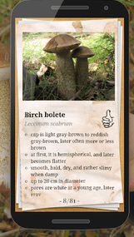 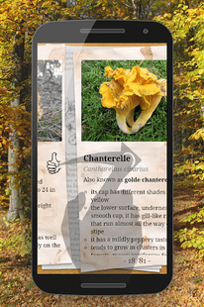 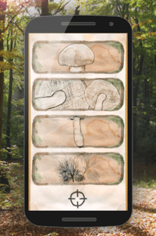

|  |  |
| --- | --- |
| Rating | Review |
| 3/5 | Would have rated it higher but the description didn't have spore print colors which would have put this app on top of a lot of apps that are free. |
| 3/5 | What does the thumbs down mean, can’t eat? and it doesn't tell you if you should cook the mushroom before or quick description on how to prepare it and its missing many mushroom types! |
| 4/5 | Couldn’t ask for a better app for mushrooms. All this needs is a way to search by season, and a way to click on the picture leading to other pictures of that mushroom. Otherwise perfect. |
| 3/5 | It's a great start. But I see nothing of the mushroom that goes by "hen of the woods" or "lobster of the woods" if you can please add as they are quite edible. Thanks. |

(App Grooves: The Mushroom Book, 2020)

Mushroom Id Guide – UK (4.4/5)

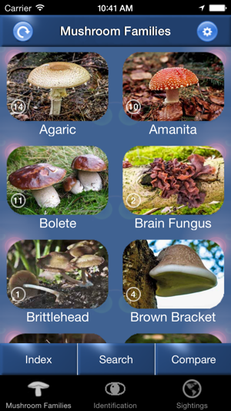 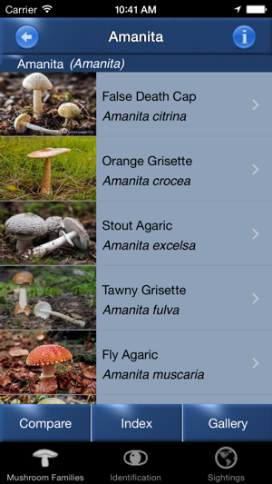 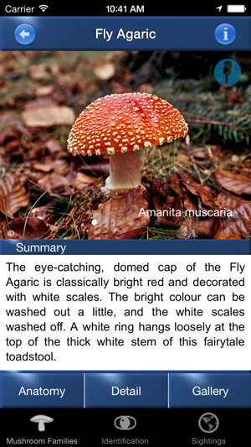 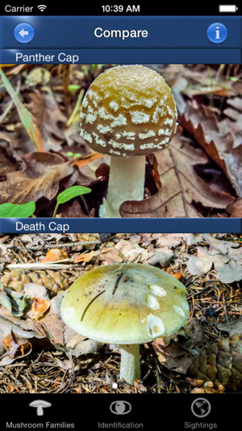

|  |  |
| --- | --- |
| Rating | Review |
| 5/5 | I really enjoy this app. The way it is set up is simple and easy to use, making it great for my family who aren't great with technology. It shows a wide range of fungi families and then within those families’ pictures and information about the individual mushrooms. I will be recommending this app to friends in the future as its perfect if you're an avid walker and want help when identifying things. It also tells you which mushrooms are poisonous, which is definitely helpful. |
| 5/5 | Firstly, I like the warning about eating wild mushrooms, even though it's a requisite it is refreshing. The pictures names are clear and distinctive, and they also have the names in Latin which is a nice touch.  I like that the mushrooms contain more than one view of the fungi. The descriptions are great, and it gives you an option to look at them in more detail, it also has an anatomy option which gives the dimensions and other key factors about a certain fungi.  As with all the Pohland & Mullen apps the identification and track your sightings feature is outstanding. This is an amazing app. |
| 1/5 | I'm an experienced mushroom hunter and I was looking for a fungi guide I could have with me all the time. Covering the British Isles, I thought it would be a good informative source for my foraging trips. However, I've found that the app has a very limited database, not enough description of each fungi, very little information about edibility (some fungi wrongly listed as inedible). Needs more photos of each mushroom. This guide might be ok for beginners but useless for more experienced people. |
| 1/5 | I have only just downloaded this. And there is so much that needs tweaking.  -When I add sighting, I need to be able to choose where I saw the fungi myself, not by using my current location  -Instead of just ‘edible’ and ‘inedible’ you need a poisonous in there and hallucinogenic? Fly agaric is a hallucinogenic… so we need more detail about taste and everything!  AND A DEATH CAP WILL KILL YOU!! So don’t just put it down as poisonous. It should be down as do not go near! And how to tell it is a death cap by its volva etc.  -I’ve payed for an app, literally handing you my money, for minimal information. Now you have my money put it into some use and care. I am so frustrated right now, also where about in England would I find these etc.  -Also, history about the fungus too!! God how can you let people pay for this! The more I play around with the app the worse I find it.  -The way to tell the mushroom apart from its imposers? A Turkeytail is flexible at any age and all of its poisonous/inedible imposters will just crumble and will be very har to move around!  -I should be able to add MORE than ONE picture on my sightings? Why can I not.  -More detail about the flavour of the edible mushrooms etc. For instance, you have a Turkeytail down as inedible, whereas in fact it is edible, it is just fowl tasting.  -The app should have a button where I can tap the Latin name and it will teach me how to pronounce it. It is a very laggy app. I am quite disappointed that I payed £4. |

(‎Mushroom Id Guide - UK on the App Store, 2020)

Mushroom Identificator (4.6/5)

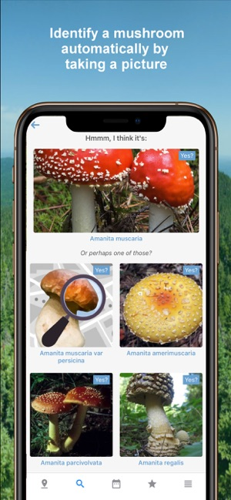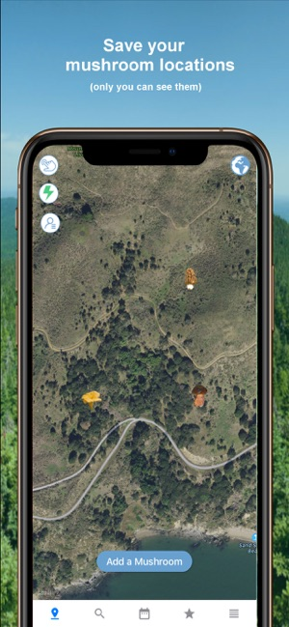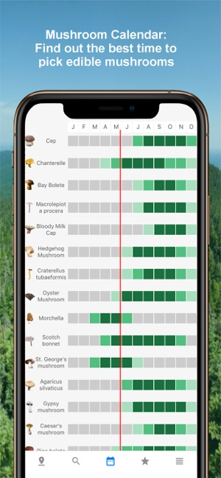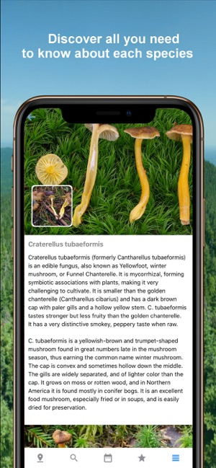

|  |  |
| --- | --- |
| Rating | Review |
| 1/5 | I took a pic of a mushroom that I could not find in either of the two books I have. After a half an hour this app was still rolling the circle trying to find it. |
| 1/5 | Tried on same mushroom at bulb, fully open top and bottom. Got 3 totally different answers and all three different. These were those common big white shrooms in your yard in Florida. |
| 5/5 | While the identifier is decent, (I wouldn’t put my life in its AI hands) the real gem is the identification quiz. Great to familiarise yourself with some of the species, with more mushrooms added in app updates. I don’t love the shooting star animation, but I don’t know if that will stay! |
| 5/5 | I love this app and use it all the time even though it gives internet links based on the photos, but that is enough to get started. AND it's really easy to use! |

(‎Mushroom Identificator on the App Store, 2020)

Web based mushroom identifiers:

<https://fungusid.com/>

<https://champignouf.com/>

<http://www.mushroom.world/mushrooms/list>

It was difficult to locate reviews for these websites and they all offered similar services to the applications, while having limited GUI. Hence, I am only offering the links.

Requested/Positive Features in Reviews:

. Include spore print colours

. App is free

. Symbols have specific meanings and are not ambiguous

. Information about how to cook/prepare the mushroom

. Ability to search for mushrooms by season

. Click on a picture which leads you to other pictures of that mushroom (plenty of reference photos)

. A warning about eating wild mushrooms

. Latin names

. App teaches you how to pronounce the Latin names

. An anatomy option specifying dimensions and other key factors

. Detailed information about edibility – poisonous, hallucinogenic, deadly, the flavour

. Save your mushroom sightings where you choose

. A mushroom calendar

. A mushroom quiz

. History about the mushroom

. Ability to add more than one image when identifying and recording sightings

. Short identification waiting times, even if it is an unknown mushroom

. Minimal latency

Prospective Users

The prospective users of my software are hikers/walkers and novice mushroom foragers. I will deliver a safe, reliable resource by sacrificing variety. Veteran mushroom hunters are experienced and know the common mushrooms as well as the most lethal species. They would only be interested in identifying rare, unusual species. This would require me to gather many more images and sacrifice quality, ultimately reducing my application’s reliability. Instead, novices have considerably less common knowledge and are prone to misidentifying mushrooms. This demographic are generally the ones who suffer the most from mushroom poisonings. Thereby my software would perfectly suit their needs because it would have all the common edible species and the most lethal species. However, as my software is updated and its mushroom encyclopaedia is expanded, it will become more suitable to experience mushroom foragers as well.

User Needs

Interview (With a prospective user)

|  |
| --- |
| How fast would you expect the app to identify your mushroom?  “Honestly it would need to be almost instantaneous otherwise the waiting may get on my nerves.” |
| How accurate would you like the identifier to be?  “I would expect it to at least identify the most common mushrooms even if the photos are a little weird.” |
| Would you prefer most of the app’s features to be predownloaded or accessible via the internet?  “Predownloaded for sure. Half the time I would use the app I would be in the middle of a forest with no connection.” |
| What information would you want displayed about the mushroom?  “Key information like its edibility, toxicity and traits are a must. The app must show an image of the mushroom it matched. I wouldn’t feel comfortable with its prediction without visual proof.” |
| Would you appreciate it if the app displayed the probability of its prediction?  “It would definitely be reassuring but I could make do as long as there was an image of the mushroom it thinks my photo is.” |
| Would you be willing to share your location if it improved the app’s predictions?  “Yeah, sure.” |
| How important would it be for the app to have an inbuilt camera function for taking photos of mushrooms and analysing for you?  “Very. It could see it being tedious having to switch to my camera app and back to the mushroom app every time I want to identify a mushroom.” |
| Would you appreciate it if the app had compatibility for images with different aspect ratios?  “Definitely!” |
| How would you like the app to look?  “As long as it’s simple and not cluttered I don’t mind.” |
| Are you comfortable with the App having terms and conditions?  “If they are short and easy to read then I have no issues with the concept.” |

My Comments

. The image processing must be quick, and it will be because of how I'm implementing the neural network. I am first training it on mathematical programming software, then transferring the result into the program. Therefore, when someone submits a new image, the CNN only executes forward propagation and the parameters don't need to change. This process halves the time taken for the program to output an answer. I am also coding the CNN with a vectorised approached which greatly improves its speed and efficiency.

. I will try to make the CNN (artificial neural network) as accurate as possible. I will use many well-known machine learning techniques and algorithms to minimise the CNN's output error. However, I can't produce a 100% chance that a mushroom matches its image. Ultimately, the probabilities produced by the CNN are dependent on the input data. I intend on having hundreds of examples per mushroom, but I am limited to the results of google and other potential search engines. Hopefully the accuracy of the CNN should increase as users submit images for training the CNN.

. After correctly implementing the CNN, I could try to create an additional CNN which has another feature for locations. I would organise the locations by region or continent, but I would need to change the number of input units in the CNN and start over testing for parameters and other variables. If I was to implement location tracking in the application, I would also need the user's permission. I wouldn't scrap the original CNN until I am sure the new CNN has proved itself to be more accurate.

. All critical features of the app will be predownloaded, this is possible because the CNN is self-sufficient. Once trained, the parameters are set. When an image is taken, it is simply feed as input data to the CNN and an answer is outputted. Reception will only be needed if the user wants to send their image to me, so I can update the CNN. I understand that users will mainly use my app when in forests and other places with poor connection. Hence it is my main priority for the app to work without a signal.

. I understand that many people would want to identify a mushroom to see whether they should pick it. Therefore, it is important for the application to display basic information about the matched mushroom. This key information will include: the mushroom's Latin name, it's other known names, is it edible/poisonous/deadly/tasty, an image of the mushroom chosen by the app. The reason someone identifies a mushroom is because they don't know what it is. Hence only knowing its name is insufficient, they need to see an exemplar image from the app, so they can judge whether the Cnn has correctly identified their mushroom.

. I will also display the probability of the matched mushroom. Ultimately if the probability is too low, the user may feel uncomfortable to trust the output. I do not want to display false information because that could lead to serious injuries and effects on the user's health. I will offer them as much information as I can while keeping the app's answer simple. All in all, it should be down to their judgment to pick/eat/cook the mushroom my CNN identifies.

. I would love to implement a photo option in the app. If I was coding for iOS, I would have an option where the user can access their camera app, then have the photo they take be used as input data for the CNN. This would be in addition to them having the option to use a photo from their library. I am also determined to make the app capable of accepting any sized image with any reasonable aspect ratio.

. I want to design the application with an interface that is intuitive and simple. If the software has functionality and simplicity, then I am sure the users will have a pleasant experience when identifying mushrooms.

. If I was to commercialise the application, I would need to implement a terms and conditions which made me exempt from any potential criticism and/or legal action.

Comparing Different Algorithm Approaches:

One verses all logistic regression:

This is the simplest supervised algorithmic solution to identify images. In theory an image’s pixels are each treated as features, these are plotted on an n-dimensional graph. This is done for all the images in the dataset – each feature has a marker which identifies which image group it belongs to. The logistic regression algorithm processes this information sequentially, treating all the data as only two groups. One group is treated normally as a group, while all the other groups are merged into one group. The algorithm forms a classification boundary around the singular group. This process repeats until each group is surrounded by their own classification boundary. The main issue with using one verses all logistic regression is when there are many overlaps in the data. Especially in the case of images when many pixels are reused, this creates unclear decision boundaries between the image groups falsifying the reliability of the model.

SVM (support vector machines) with similarity functions/kernels:

SVM is another supervised learning algorithm. It differs to logistic regression by mapping the logistic cost curve onto two linear vectors. This results in a clearer decision boundary for making predictions. For multiclass classification we pair the algorithm with a similarity function. This function generates landmarks – one landmark per example. It calculates the distance between the input data and the landmarks and records the output as features. These features are used in the SVM to calculate the costs which can be used in a minimisation algorithm to optimise the parameters, improving the success rate of predictions. This algorithmic pair is a popular approach in the industry for multiclass classification because it has the potential to train faster than even neural networks. However, this benefit only applies when the algorithm is incredibly well built. Compared to the other algorithms, there are many more variables in SVM which can reduce the success rate of predictions. For instance, there are so many simplicity functions I could choose from: the polynomial kernel, string kernel, chi-square kernel, histogram intersection kernel, etc. It would take a lot more research and many more attempts for me to produce an efficient SVM than an efficient neural network.

K means algorithm:

K means is an unsupervised multiclass classification algorithm. It revolves around two components – clusters and centroids. First the data is plotted in an n-dimensional space. Centroids are placed randomly in this space – there is a centroid for each group. Each data is matched to the centroid it is closest to. The centroids are shifted to where the average of their data is. The data is reassigned to their’ new closest centroid. This processing of shifting and reassigning is repeated until the centroids no longer move. The algorithm is tailored for unsupervised learning, since I am taking a supervised approach it would be irrelevant to model my predictions on this algorithm. It could have applications for grouping the images I web scrape but is not a necessity.

Convolutional Neural Networks (CNNs):

CNNs can take either supervised or unsupervised approaches depending on the algorithms you use within them. I am focussing on supervised CNNs which use the logistic regression algorithm as their cost function. All CNNs use the forward and backwards propagation algorithms for traversing the network. The input layer of the network is designated to the input data and the output layer is a vector of ones and zeros which represent the prediction. They are the most popular approach among data scientists for image classification because they offer an easy solution to the bias-variance trade-off. Through changing the dimensions of the network, one can create a balanced model comparatively quickly. Therein I believe building a CNN is my most viable solution for identifying mushroom species.

Text User Interface vs Graphical User Interface

|  |  |  |
| --- | --- | --- |
|  | Text User Interface | Graphical User Interface |
| Advantages | . The code is much simpler to write.  . Code is faster.  . The file size of the application will be reduced. | . A lot of customisability.  . User need to do minimal typing  . It appeals to a larger demographic – people are often intimidated by |
| Disadvantages | . I would need to supply instructional commands to the user.  . The interface is not visually appealing.  . I can’t style the interface.  . Navigating the application is slower for the user. | . It requires a GUI library which increases the application’s file size.  . I will need to learn the operations of the GUI library I chose.  . Integrating the database and neural network within the application will be harder using a GUI. |

I have chosen to build the interface graphically rather than text base because it adds complexity to the project and offers me greater scope for customisation and stylisation.

Kivy vs Tkinter

|  |  |  |
| --- | --- | --- |
|  | Tkinter | Kivy |
| Advantages | . It is a tried and tested library.  . It has a large community and a lot of documentation.  . Tkinter is very intuitive.  . It supports Linux, MAC OS and Windows. | . Kivy runs on Linux, Windows, OS X, Android, iOS and Raspberry Pi.  . Widgets are built with multi-touch support.  . It has its own CSS like styling language which makes coding interfaces much simpler.  . It comes with a huge variety of built in widgets ready for use. |
| Disadvantages | . It does not support iOS, android or Raspberry Pi.  . Its built-in widgets and templates are very basic. | . There isn’t much documentation.  . The Kivy community is very small.  . Kivy is a new GUI development library. |

For me, the main highlight of Kivy is its styling language. I love the idea of being able to separate the interface’s functionality from its visuals and the Kivy language allows me to do this. Using their language will make it a lot easier for me to edit and write code. For this reason and the library’s large variety of premade widgets, I have chosen Kivy over Tkinter for building my application’s interface.

Python Machine Learning Library Comparison:

|  |  |  |
| --- | --- | --- |
| Library | Background | Features |
| TensorFlow | . The library was designed to be used in machine learning.  . It originates from Google’s machine learning software.  . It was released in 2015, but after a decline in 2016 TensorFlow2.0 was developed and released in 2019. The current version made the library simpler and more user friendly. | Advantages  . You build a stateful dataflow graph  . It has a lot of pretrained models with quick access.  . It has many popular ML algorithms and datasets ready for use.  . You can access ‘Google Research’ datasets.  . For mobile development it has APIs for JavaScript and Swift.  . It is a large community and there is plenty of documentation.    Disadvantages  . It is comparatively slow library.  . There is a lot of syntax to learn.  . The library is large in file size. |
| PyTorch | . PyTorch was developed by Facebook and released in 2016.  . It was created as an alternative to other ML libraries with models being comparatively easier to write.  . It is based on Torch – a framework written in C that specialises in fast computation. | Advantages  . Provides sensible error messages.  . Very compatible with NumPy.  . Fast.ai makes it extremely easy to build models quickly.  . It is highly optimised and uses minimal memory for tasks because its underlying language is C/C++.  . It offers tight control of the model structure.    Disadvantages  . It has few prebuilt datasets.  . There is a lot of syntax to learn.  . The library is large in file size. |
| OpenCV | . OpenCV is a library tailored for specifically computer vision.  . It was developed by Intel and first released in 2006.  . it is written in C/C++. | Advantages  . Being written in C/C++ means it is faster than most other python ML libraries.  . It has more than 2,500 ML algorithms built in.  . It uses comparatively low RAM  . Large corporations like IBM, Toyota and Google use it, so it must be reliable.  . It takes advantage of hardware acceleration and multi-core systems.    Disadvantages  . It has few prebuilt datasets.  . It specialises in computer vision |
| Pandas | . Pandas was developed by Wes McKinney and first released in 2008.  . Later in 2012 it was significantly improved by Chang She. | Advantages  . It provides extremely streamlined forms of data representation.  . It offers many new import commands and features for analysing features.  . It imports large amounts of data very fast.  . It is a tried and tested reliable library.    Disadvantages  . The syntax is complex  . Poor documentation  . Poor 3D matrix compatibility |
| NumPy | . It is an essential ML and mathematics library in Python.  . NumPy is by far the oldest of the libraries. Its original developer was Jim Hugunin and its first release was in 1995. | Advantages  . It is used to transform arrays.  . NumPy arrays are faster than Python lists.  . It provides many mathematical functions that are necessary in ML.  . It is smallest in file size of all the other libraries.  . Many ML packages like Keras and SciPy have NumPy within them.    Disadvantages  . It does not contain any machine learning functions, datasets or models. |
| Matplotlib | . It is not a ML library by itself but most ML libraries use it to visualise their models.  . Developed by John Hunter’s and initially released in 2003 it is another old library. | Advantages  . You can create an incredibly diverse number of visualisations.  . It couples well with pandas.  . It is based on a visualisation stack, making customisation of visuals easier.  . Matplotlib2.0 has much nicer styling capabilities and allows you to theme visualisations with minimal effort.    Disadvantages  . Its two interfaces can cause confusion. The first is derived from MATLAB and is state based, while the other is object-oriented based. |

Evaluation:

As stated previously, I plan to train the network in GNU Octave. Therefore, I will only need to execute the forward propagation algorithm in python. This implies I have no need to plot data. Therein the best library for me is NumPy. It is the smallest in file size and offers sufficient functions for me to build the network and execute forward propagation. The parameter and database data will take up a lot of space, so I want to reduce the space used by other files in the application as much as possible.

Acceptable Limitations

Time is the only issue when it comes to creating this software. I would ideally have it be deployable on iOS and Windows, but the UI on both systems would be vastly different. I can make the software compatible for Windows and MacOS thanks to the python library Kivy. However, if I was to map it onto iOS, I would need to completely redesign its layout, allowing a camera features and potentially a GPS tracking system; which would all have to be rewritten in Xcode.

Therefore, I will only attempt to transfer the software onto iOS once I've succeeded at implementing it in Windows. Other limitations include my potential pool of images. Since I plan on creating my own dataset, I am limited to the number of hours I am willing to sought through images. I am also limited by the search results of google; one search result produces a maximum of 750 images.  Bear in mind, many of the images will also be duplicates or completely irrelevant. This makes for a small training set to work with unless I input weeks of work.

Since I plan to use Kivy as my GUI library, I have access to a range of sophisticated widgets and designs. However, I am still limited to its selection, and unable to create my own widgets.

Creator of ‘FungusID’

According to ‘Old Man of the Woods’, when creating FungusID he encountered several issues related to collecting the input data. He often found images of mushroom candles and other items when searching for a specified mushroom. It took him and his wife many hours to sought through the data and turn it into reliable input data. He also prioritised mushrooms in the region where he lived, as there are simply so many varieties of mushrooms in the world. Additionally, he was also limited by Google’s lack of mushroom images, when it came to finding images of rare/specific mushroom’s the search would give very few correct results. This led to FungusID offering accurate predictions for popular mushrooms but inaccurate predictions for rare mushrooms. (FREE! Mushroom Identification AI Assistant - Youtube, 2020)

This further emphasises that collecting a large pool of images will be tedious and a definite limitation of my software.

Objectives

Having gathered information from a variety of sources, I decided to have a discussion with a small group of potential users – including vegans, avid walkers and beginner mushroom foragers. The following objectives are the results of our discussions.

Primary Objectives:

1)     A main menu with an exit button and widgets for the mushroom encyclopaedia, identification, calendar and contacting me.

2)     User can type the file location of the mushroom they wish to identify.

3)     The app must identify the mushroom in under 5 seconds.

4)     Once the mushroom is identified, the user is given a list of the 3 most likely mushrooms with probabilities and images.

5)     If they select a mushroom, additional information about it will appear.

6)     If the user clicks the image again more images of the mushroom will appear.

7)     A back button will always be present.

8)     The transitions between windows is smooth and quick.

9)     The app will be fully functional without connection to the internet (except if they want to send me their mushroom images).

10)  All this information could also be accessed via the encyclopaedia

11)  A calendar displays the seasonality of mushrooms in alphabetical order

12)  A contact window displays my contact information

Neural Network Objectives:

1)     Efficiently scrape images from google with minimal mistakes.

2)     Successfully convert the images into ordered, usable data.

3)     Construct the neural network so it is flexible and able to accommodate new mushrooms.

4)     Successfully train the network and minimise the parameters.

5)     Achieve consistent predictions above 90% for mushrooms registered in the network.

6)     Translate the code into python and successfully integrate it within the GUI.

Potential Solution

I plan on using 2 programming languages for developing the application; Octave and Python. For creating and training the neural network I will be using Octave. It has a vast range of mathematical functions and is an ideal language for building machine learning algorithms. However, once the network is trained and the variables are decided, I plan to recode it in python using the variables I have optimised. Python has many machine learning libraries such as Keras and NumPy which will allow me to do this. I will also be developing the application’s GUI using Kivy – a python library. Having all parts of the application written in python will improves their compatibility with each other. Kivy also operates on Windows, Android, iOS, Linux, MacOS, hence I don’t need to rewrite my program in other languages like SwiftUI if I want compatibility with new OS.

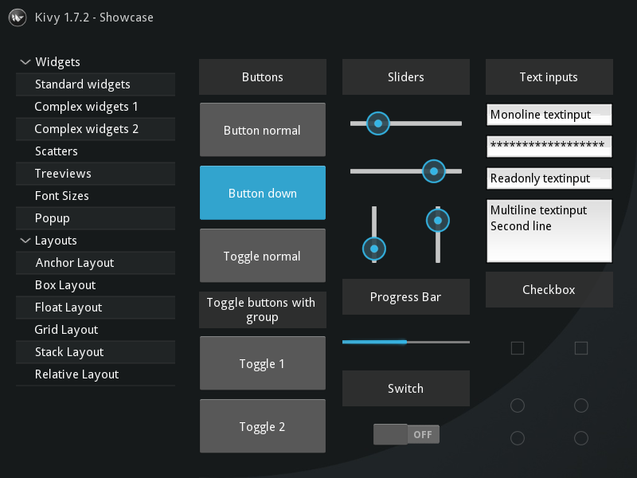

This image gives an idea of widget designs Kivy offers, which I will be using.

# DESIGN

The Process

Creating my dataset

. Search the mushroom I want in google and traverse to the image section, scroll to the bottom so 750 images are available.

. Use a script coded in JavaScript to collect all the images as a list of URLS.

. Run a python script which converts the list of URLS into images and downloads them onto a file.

. Sought the images with Visipics to remove duplicates.

. Manually sought through the images to remove anomalies and false images.

. Run an image augmentation script on the images to artificially increase the size of the dataset.

. To convert the images into useable data, transfer them to the dataset constructor algorithm.

Creating and training the CNN/convolutional neural network

. Set the initial dimensions of the CNN to a 3-layer network with 10000 input units.

. Randomise the initial parameters using the random parameter generation algorithm.

. Divide the data into training and testing data in the ratio 4:1.

. Perform forward and backwards propagation for each example/image and run the gradient descent algorithm for each example to minimise the cost function (error in the parameters – part of back propagation).

. Plot the various graphs and outputted probabilities to ensure the parameters are being optimised.

. When the parameters are optimised, they are saved in a csv file.

. The CNN is recoded in python to the same dimensions and using the parameter I have calculated.

Building the application

. Build the network and forward propagation algorithm in python.

. Create the class for automating adding items to the database.

. Build the database and save it as a csv file.

. Build the graphical user interface using the Kivy language for styling the visualisations and python for the implementing the program’s functionality

Graphical User Interface (GUI) Design

When designing the GUI, I was heavily inspired by the designs of the applications I previously analysed. The ‘Mushroom Identificator’s’ style was my favourite because of its modern, simplistic appearance. My designs are also tailored to the widgets and layouts the python Library ‘Kivy’ will provide.

This is the main menu. On it are 4 buttons which lead to the other GUI’s further down. The arrows link widgets to the windows they produce. The identify, encyclopedia and calendar widgets open their respective windows below who’s title matches their title.

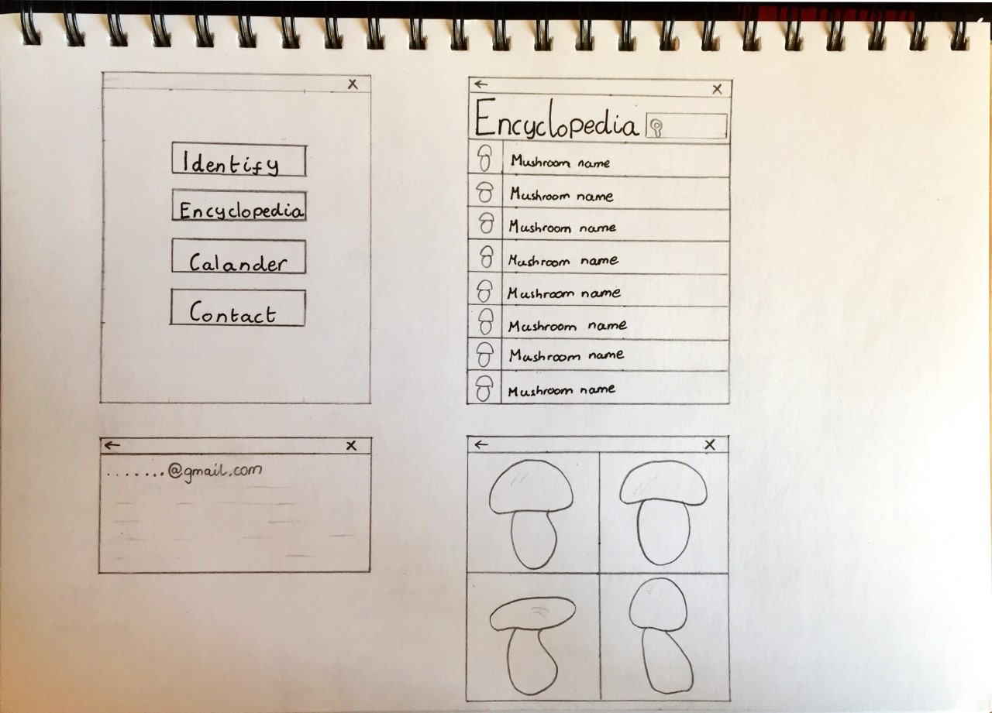

Selecting the contact button opens the contact window. Here my email and other potential contact details are displayed to the user so they can send me their mushroom photo.

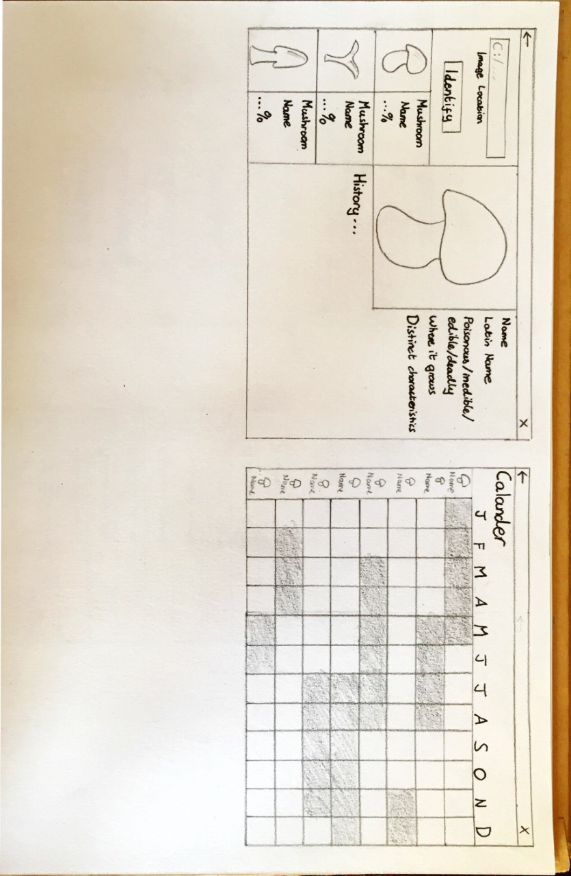

If the image is selected, a new window containing 4 more images of that mushroom type will open. Mushrooms vary greatly in appearances, even if they are in the same species. Hence, giving the user a pool of images for confirmation is the safest option.

When the encyclopaedia widget is selected, the encyclopaedia window is opened. This window consists of a list of mushroom names ordered alphabetically, each paired with their own image.

If the user selects a mushroom, then the mushroom information window opens. This window displays an enlarged version of the image of the mushroom from the previous window as well as a brief history of it, its edibility, defining characteristics and other crucial information. This window is where the majority a mushroom’s information is displayed.





Selecting the identify button, opens the identify window. Here the user enters the file location of the image they want to identify. Underneath, the 3 mushrooms with the highest probabilities are displayed. Depending on which mushroom the user selects, its corresponding information window will be shown, with the same features as previously explained.

Selecting the calendar widget opens the calendar window. The left most column contains a list of alphabetically ordered mushrooms with images. Each column on the right represents a month of the year. Each mushroom has its own row. The shaded regions signify when a specific mushroom grows. This will be another form of confirmation for the user when they are identifying mushrooms.

GUI Inheritance diagram

The diagram to the left is a simplified representation of the classes that will build the graphical interface. The App, Screen Manager and Screen classes are all classes built into the Kivy library. All my window classes inherit the properties from the Screen class, which allows them to be formatted as window.

The Window Manager inherits from Scree Manager, so it can control the transition between windows and the data transmission between windows.

Almost all classes in Kivy are descendants are the App class because this is the class that builds and implements the application. Hence, the App class is the root of the inheritance tree.

There are many other classes and sub classes, that the classes I build will inherit from but they all fall under the fundamental classes listed in the diagram. Additionally, in the Kivy language layout classes are not inherited but referenced so there is less to consider when styling the interface.

This diagram focuses on the core features of the application which is why the calendar and contact window classes are not included.

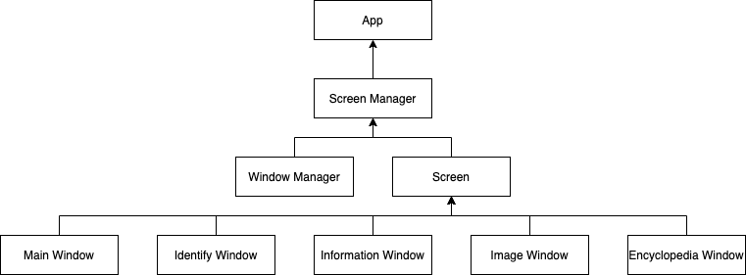

Relational Database Design

It was very difficult to find interlinking features between different mushroom species because mushrooms are so unique – they vary in size, shape, colour, body type etc.

Of the six fields in the information table only two needed to be separated in to separate tables: season and features. The seasons could be split into the 12 months of the year and since many mushrooms would overlap in seasons it made sense to dedicate an entire table to the seasons mushrooms grow in.

In comparison, a mushroom’s features are a lot harder to separate into specific fields and tables. Upon careful abstraction it became clear to distinguish a mushroom’s features into 4 categories: its body, the environment it grows in, how it grows and its type of underside. I could not split these into fields because each category contained subcategories as well. Therefore, I gave each category its own table with fields within that described the traits of the mushroom in more detail.

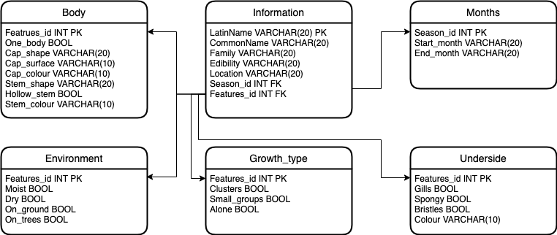

Data Requirements

|  |  |  |  |  |
| --- | --- | --- | --- | --- |
| Name | Purpose | Type | Maximum Size | Example |
| Mushroom name | Stores the name of the mushroom species | String | 20 | Bolete |
| Month | If a mushroom grows in the month then the month is shaded | Boolean | 1 | 1 |
| Species Image | Every mushroom is given an image for users as a reference | Integer | 1000 |  |
| Dataset | An array of all the mushroom images in numerical form. | Integer | Undefined | [255,108,012] |
| Species data | A cellular array containing information of each species of mushroom. | String | undefined | {poisonous, deadly} |
| Probability | To show how accurate the software is at predicting a mushroom. | float | 100 | 92.5 |
| Email | Allows the user to send pictures of mushrooms to me and asked questions. | string | 30 | …@gmail.com |
| Warning | To inform users of the risk of foraging and eating wild mushrooms. | string | 100 | Ingesting wild mushrooms may mean certain death. |
| Encyclopedia | A cellular array which stores the mushroom names and their respective images. | Any | undefined |  |
| Calendar | An array of Boolean variables, which display what seasons mushrooms grow in. | Boolean | Undefined |  |

Neural Network Algorithms

|  |  |
| --- | --- |
| Algorithm | Purpose |
| Dataset Constructor | It imports the images I scrape from google and converts them into a matrix of usable input data. |
| Random Parameter Generator | It generates the first versions of the parameters for each layer of parameters in the network |
| Forward Propagation | It traverses through the neural network layers, calculating values for the activation units and hypothesis. |
| Backwards Propagation | It traverses backwards through the neural network, calculating the distribution of errors within the parameters. |
| Cost Function | It calculates the error in the network’s predictions. |
| Fmincg | It minimises the error in the network’s predictions. |
| Image Converter | It converts the images inputted by the user into usable data. |

Dataset Constructor:

The mushroom images will be stored under one folder, with each species having its own sub-folder. The algorithm will collect all the images and store them in a cellular array; each species has its own row. The images are sequentially processed, one mushroom at a time. First, they are converted into a grayscale format, then reshaped to a size of 100 by 100 pixels, unrolled into single row vectors and labeled with numbers that represent their species. Each mushroom has its own row in the array of integers and the algorithm records which rows the species change.

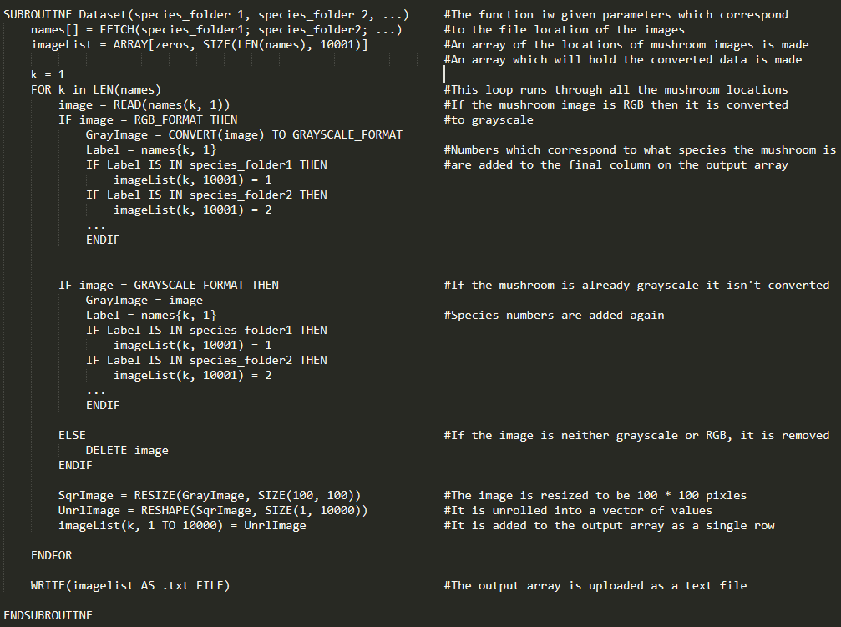

Random Parameter Generator:

For each layer of parameters, the algorithm generates a matrix with the same dimensions as the specified layer and with values within the range of epsilon and minus epsilon (epsilon is usually around 10%).

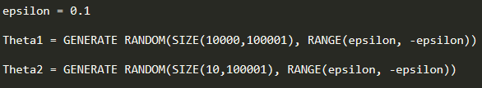

Cost Function:

For my problem I am using a logistic cost function because its outputs suit my classification CNN.





(Ognjanovski, 2020)

The algorithm will be taking a vectorized approach, hence the summations in the equation above won’t be needed. In addition, the component on the right for regularisation will be computed separately, by adding the sum of all the parameters.

Forward Propagation:

This algorithm calculates values of the activation units. It will start at the beginning of the neural network by multiplying the vector of input units with the first layer parameters. This should result in a vector of values with the same size as specified for the layer. Each value in that layer has the activation function (sigmoid function) applied to it, resulting in a vector of activation units. This process continues with the current layer of activation units as the input units and the next layer parameters. Once all the units in the network are activated and the algorithm has reached the output units, a hypothesis is calculated and with it so is the cost function.

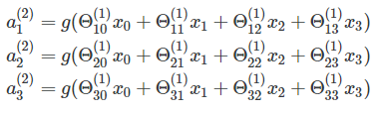



(Ognjanovski, 2020)

The a’s represent the activation units in layer 1, while the h(x) represents the hypothesis/output layer.

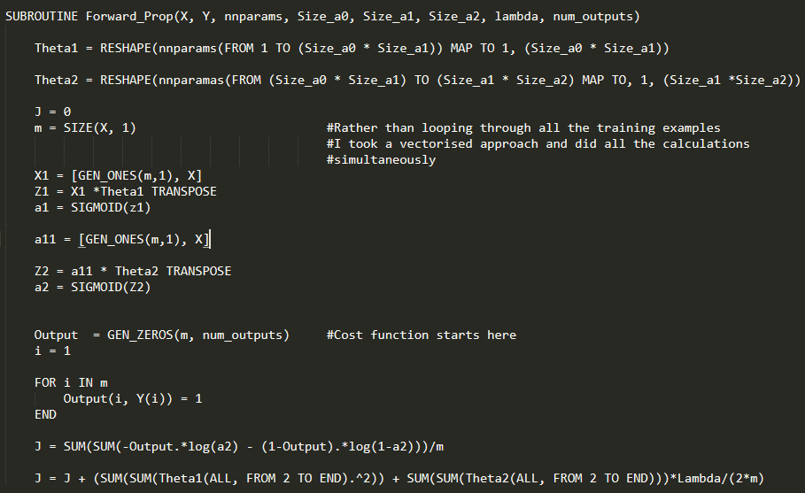

Backwards Propagation:

Back propagation starts at the end of the network, by calculating a basic error between the prediction and actual output. It then proceeds to calculate the partial derivatives for the parameters behind the output layer. The errors for the activation units in the final hidden layer are calculated and this process repeats until the algorithm reaches the final layer of parameters.

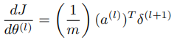

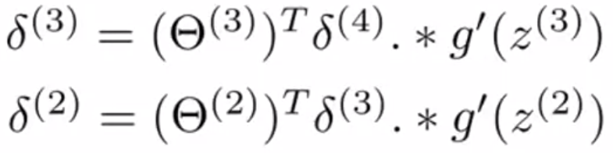

(Ognjanovski, 2020)

The top equation describes how the partial derivatives are calculated and the bottom equations show how the deltas are calculated which are used in the top equation.

Fmincg:

It is an advanced optimisation algorithm built inside Octave for the sole purpose of minimising the cost function. Minimising the cost function means minimising the error, therefore optimising the network. Fmincg uses the partial derivatives calculated by propagation to operate. There are more famous optimisers like gradient descent which work on a similar premise but in my case Fmincg is more effective.

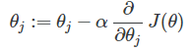

(Ognjanovski, 2020)

The equation above shows the process of gradient descent to offer an idea of how Fmincg operates.

­Image Converter:

It starts by finding the path of the image specified by the user. It then fetches the image, checks whether it is compatible with the system, then begins the process of conversion. First it converts it to grayscale format, then it resizes the image to be 100 by 100 pixels and unrolls it into a single vector with dimensions 1000 by 1, with each pixel value representing an input unit in the neural network.

General process

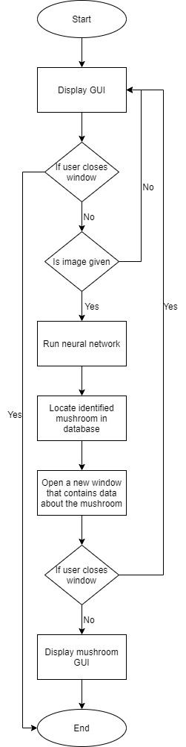This flow diagram was halved because of its length, bare in mind the bottom and the top of these diagrams are connected.

Random Parameter Generator

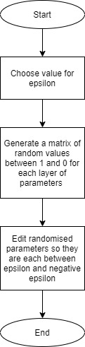This flow diagram describes the process of the random parameter generator algorithm.

Untrained Neural Network

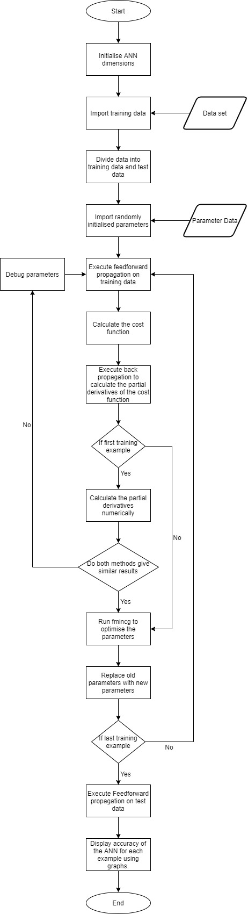This flow diagram illustrates how the untrained neural network operates.

Trained Neural Network

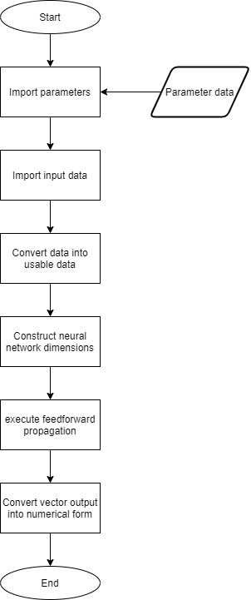The flow diagram underneath demonstrates how the trained neural network functions.

Test Plan

|  |  |  |  |
| --- | --- | --- | --- |
| No | Test | Test Data | Expected Outcome |
| 1. | Click each widget at least once. | Normal | The widgets will all operate normally. |
| 2. | Type a file location in the text box which does not exist. | Erroneous | The pop-up window that explains the file location the entered does not exist will appear. |
| 3. | Attempt to use an SQL injection in the text box. | Erroneous | The pop-up window that explains the file location the entered does not exist will appear. |
| 4. | Use ‘\’ instead of ‘/’ when typing the file location. | Erroneous | The pop-up window that explains the file location the entered does not exist will appear. |
| 5. | Give the application an image of a mushroom that I know is on the database. | Normal | The application will successfully predict the species of mushroom and display information about In another window. |
| 6. | Give the program images with different aspect ratios. | Normal | The program will work as expected, making a prediction and displaying information about the mushroom it predicts. |
| 7. | Give the application an image which is not a mushroom. | Boundary | The application will still predict a mushroom. |
| 8. | Give the application a corrupted image. | Boundary | The software will try to identify it then stop running. |
| 9. | Give the program the file location of a file that is not an image file, e.g. a document. | Erroneous | The software will try to identify then stop running. |
| 10. | Type the path of images with different file formats into the text box. | Normal | The CNN will operate the same for each format and make the best predictions it can. |

# Technical Solution

Stage1: Making the dataset

Part1: Collecting the data (Javascript and Python)

//JavaScript Code

// pull down jquery into the JavaScript console

var script = document.createElement('script');

script.src = "https://ajax.googleapis.com/ajax/libs/jquery/2.2.0/jquery.min.js";

document.getElementsByTagName('head')[0].appendChild(script);

// grab the URLs

var urls = $('.rg_di .rg_meta').map(function() { return JSON.parse($(this).text()).ou; });

// write the URls to file (one per line)

var textToSave = urls.toArray().join('\n');

var hiddenElement = document.createElement('a');

hiddenElement.href = 'data:attachment/text,' + encodeURI(textToSave);

hiddenElement.target = '_blank';

hiddenElement.download = 'urls.txt';

hiddenElement.click();

#Python Code

# import the necessary packages

from imutils import paths

import argparse

import requests

import cv2

import os

# construct the argument parse and parse the arguments

ap = argparse.ArgumentParser()

ap.add_argument("-u", "--urls", required=True,

    help="path to file containing image URLs")

ap.add_argument("-o", "--output", required=True,

    help="path to output directory of images")

args = vars(ap.parse_args())

# grab the list of URLs from the input file, then initialize the

# total number of images downloaded thus far

rows = open(args["urls"]).read().strip().split("\n")

total = 0

# loop the URLs

for url in rows:

    try:

        # try to download the image

        r = requests.get(url, timeout=60)

        # save the image to disk

        p = os.path.sep.join([args["output"], "{}.jpg".format(

            str(total).zfill(8))])

        f = open(p, "wb")

        f.write(r.content)

        f.close()

        # update the counter

        print("[INFO] downloaded: {}".format(p))

        total += 1

    # handle if any exceptions are thrown during the download process

    except:

        print("[INFO] error downloading {}...skipping".format(p))

# loop over the image paths we just downloaded

for imagePath in paths.list_images(args["output"]):

    # initialize if the image should be deleted or not

    delete = False

    # try to load the image

    try:

        image = cv2.imread(imagePath)

        # if the image is `None` then we could not properly load it

        # from disk, so delete it

        if image is None:

            print("None")

            delete = True

    # if OpenCV cannot load the image then the image is likely

    # corrupt so we should delete it

    except:

        print("Except")

        delete = True

    # check to see if the image should be deleted

    if delete:

        print("[INFO] deleting {}".format(imagePath))

        os.remove(imagePath)

To execute the code, I first searched for the mushroom using its common name in the search bar. I scrolled down the page until I reached the bottom of the image window (720 images in total). I inserted the JavaScript code above into the search engine’s control panel and executed it. The code generated a list of URLs and saved them as a text file in a location I chose. I then executed the python file to convert the list of URLs into images and saved them within a file labelled with the specie’s name. I searched for the same mushroom again but used its Latin name. This process repeated as I searched for the same mushroom using different versions of its name (this included different languages). I only moved onto the next species if I were satisfied with the number and the variety of images I had collected.

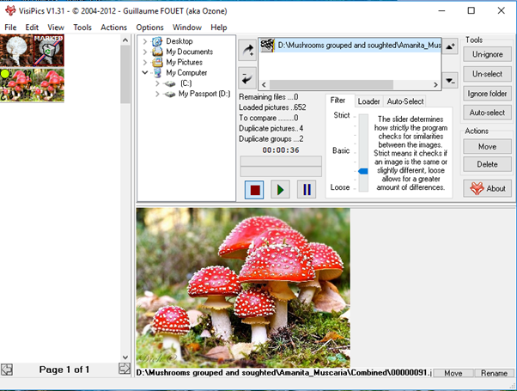Part2: Refining the data

I used Visipics (a free image duplication detection software) to scan for any duplicates of images and remove them. The software allowed me to alter the accuracy of its matching, so I could not only discard images that were identical but also images that were comparatively similar in their pixels.

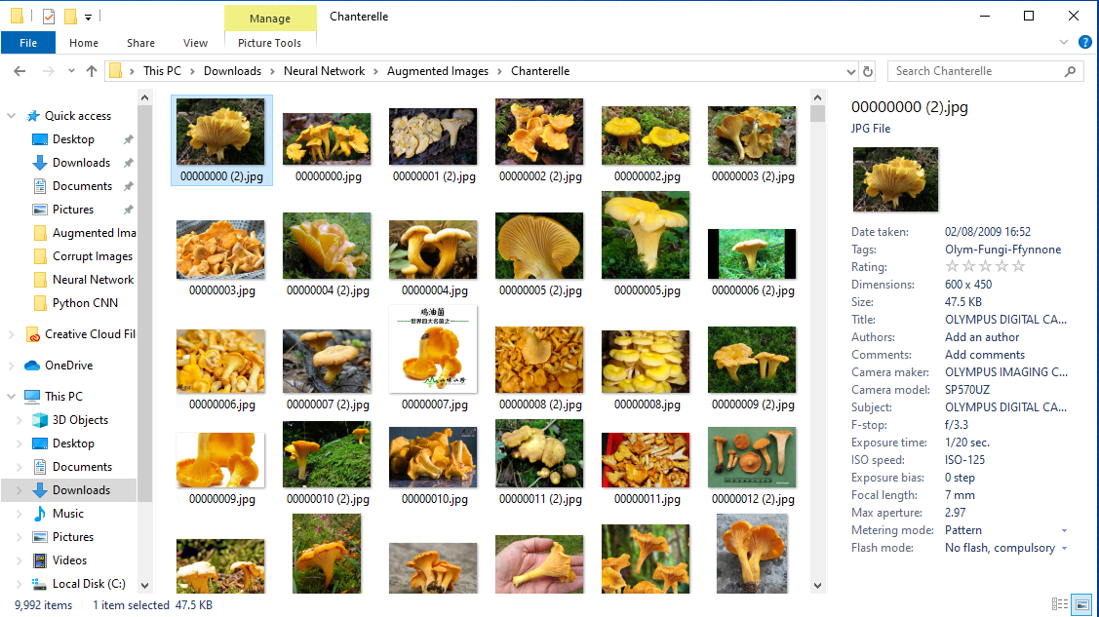

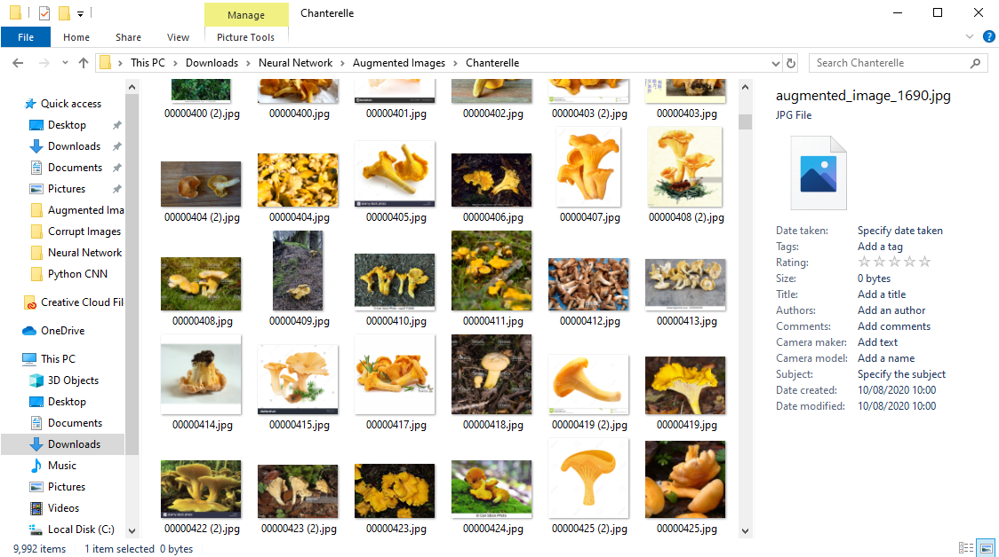

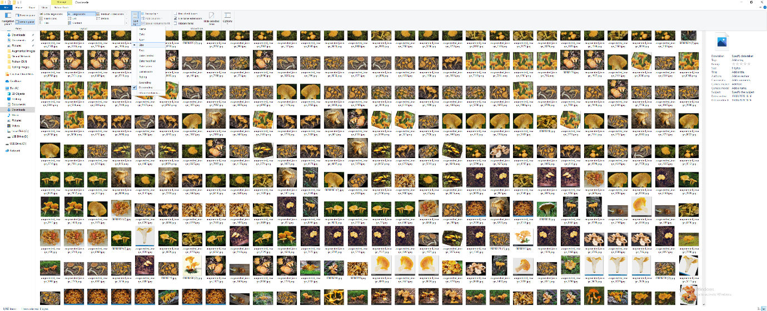

The next step was to remove corrupt images. I first located several corrupt images within a selection of the image folders (corrupt images have no image icon). All their properties varied except for one; their size of zero bytes. Knowing this, I used the Sort by Size feature under the View header in File Explorer to sort the images by their file size. This grouped all the corrupt images in one location, which made it easy for me to remove and transfer them to the corrupt image folder.

The final step was to manually sort through all the images and identify if there were any outliers in images that I collected. There were many images that were not the mushrooms I searched for. It took several weeks for me to sort through only 10 species and I am sure there were a few images which escaped my filtering. However, I believe I removed most of the false mushroom images.

Part3: Augmenting the data (Python)

import os

import random

from scipy import ndarray

# image processing library

import skimage as sk

from skimage import transform

from skimage import util

from skimage import io

def random_rotation(image_array: ndarray):

    # pick a random degree of rotation between 25% on the left and 25% on the right

    random_degree = random.uniform(-25, 25)

    return sk.transform.rotate(image_array, random_degree)

def random_noise(image_array: ndarray):

    # add random noise to the image

    return sk.util.random_noise(image_array)

def horizontal_flip(image_array: ndarray):

    # horizontal flip doesn't need skimage, it's easy as flipping the image array of pixels !

    return image_array[:, ::-1]

# dictionary of the transformations we defined earlier

available_transformations = {

    'rotate': random_rotation,

    'noise': random_noise,

    'horizontal_flip': horizontal_flip

}

# The folder containing the images

folder_path = 'D:/Mushrooms grouped and soughted/Hen_of_the_Woods/Combined'

# The number of files to generate

num_files_desired = 9340

# find all files paths from the folder

images = [os.path.join(folder_path, f) for f in os.listdir(folder_path) if os.path.isfile(os.path.join(folder_path, f))]

num_generated_files = 0

while num_generated_files <= num_files_desired:

    # random image from the folder

    image_path = random.choice(images)

    # read image as an two dimensional array of pixels

    image_to_transform = sk.io.imread(image_path)

    # random num of transformation to apply

    num_transformations_to_apply = random.randint(1, len(available_transformations))

    num_transformations = 0

    transformed_image = None

    while num_transformations <= num_transformations_to_apply:

        # a random key from the dictionary is chosen

        key = random.choice(list(available_transformations))

        # the key's corresponing value (transformation function) is performed on the image

        # This is repeated on the transformed image depending on the num_transformations_to_apply, to get an image with a random combination of transformations

        image_to_transform = available_transformations[key](image_to_transform)

        num_transformations += 1

    #After the image is fully transformed, it becomes officially transformed

    transformed_image = image_to_transform

    #Since some of my images where already png, they cannot my transformed directly to jpg, that will be done in octave.

    #jpg doesn't have alpha channel, so when a png image is saved as a jpg an error occurrs, this triggers the exception to save

    #the image as png instead

    try:

        #The transformed is assigned a path to be saved at

        new_file_path = 'C:/Users/Dale/Downloads/Neural Network/Augmented Images/Hen_of_the_Woods/augmented_image_%s.jpg' % (num_generated_files)

        # write image to the disk

        io.imsave(new_file_path, transformed_image)

    except:

        new_file_path = 'C:/Users/Dale/Downloads/Neural Network/Augmented Images/Hen_of_the_Woods/augmented_image_%s.png' % (num_generated_files)

        io.imsave(new_file_path, transformed_image)

    #I would prefer to save files as jpg rather than all png, because jpg generally use less disk space, which is a valuable resource (png is a lossless format)

    num_generated_files += 1

# Augmenting the images gave me a total of 100,000

# But I only applied 3 transformations so there were a few duplicates

Part4: Constructing the dataset (Octave)

 function dataset2

  #This code locates the file location of the images

  #and stores the image file locations in arrays

  #Each species is assigned to their unique variable

  A = glob('Amanita_Muscaria\*.jpg');

  B = glob('Chanterelle\*.jpg');

  C = glob('Enokitake\*.jpg');

  D = glob('Field_Mushroom\*.jpg');

  E = glob('Hen_of_the_Woods\*.jpg');

  F = glob('Horn_of_Plenty\*.jpg');

  G = glob('Morel\*.jpg');

  H = glob('Oyster\*.jpg');

  I = glob('Penny_Bun\*.jpg');

  J = glob('Shiitake\*.jpg');

  #I created a cellular array and normal array because they both have specific

  #attributes which I will need later on

  #File names of the images stored in an array

  #File names of the images stored in a cellular array

  #A matrix of zeros with the dimesnsions of the output is created

  names = [A; B; C; D; E; F; G; H; I; J];

  names2 = {A; B; C; D; E; F; G; H; I; J};

  imagelist = zeros(length(names), 10001);

  #For loop loops through all the mushroom file names

  #Convert the filename to image data

  for k = 1:length(names)

    image = imread(names{k, 1});

    check = names{k, 1};

    #Checks if image is RGB

    #If it is, it converts it to grayscale

    #This code assigns a number to each image

    #This label is stored in the last column

    if size(image, 3) == 3

      GrayImage = rgb2gray(image);

      for i = 1:length(names2)

        if ismember(check, names2{i})

          imagelist(k, 10001) = i;

        end;

      end;

    #If the image is already grayscale

    #it is kept in the same format

    #Again, this code lables the images

    elseif size(image, 3) == 1

      GrayImage = image;

      for i = 1:length(names2)

        if ismember(check, names2{i})

          imagelist(k, 10001) = i;

        end;

      end;

    #If the image is neither RGB or grayscale format

    #it is removed

    else

      bin = image;

    end

    #The image is resized to be 100*100 pixels

    #The resized image is unrolled into a row vector of 10000 columns

    #The unrolled image is stored in columns 1 to 10000 of the matrix

#imagelist

    SqrImage = imresize(GrayImage, [100, 100]);

    UnrlImage = reshape(SqrImage, 1, 10000);

    imagelist(k, 1:10000) = UnrlImage;

  end;

  #The matrix of images 'imagelist' is uploaded as a .txt file

  #(with the same format as a csv file)

  dlmwrite('mushroomdata3.txt', imagelist)

endfunction

 #Creating the code for labeling the images with numbers was very hard

 #I had to be very specific in how I used cells and arrays to

 #accomplish my goal

 #Optimising this section of code was by far the most challenging part of

 #coding this function

Stage2: Training the network (Octave)

Random weight initialisation algorithm

function W = randInitialiseWeights(L_in, L_out)

  #parameters given the dimensions of their corresponding layer

  W = zeros(L_out, 1+L_in);

  epsilon_init = 0.12;

  #parameters randomly generated between epsilion and -epsilon

  W = rand(L_out, 1+L_in)*(2*epsilon_init)-epsilon_init;

endfunction

Image distribution function

function [trainData,testData] = distribute(p)

  m = size(p, 1);

  #ordered data is shuffled for randomisation

  shuffled = p(randperm(size(p,1)), :);

  #calculate the number of train examples

  trainSize = round(m*0.8);

  #calculate the number of test examples

  testSize = round(m*0.2);

  #training data taken from the input data

  trainData = shuffled(1:trainSize, :);

  #testing data taken from the input data

  testData = shuffled((trainSize+1):end, :);

endfunction

#The function is designed to randomly shuffle the images in the dataset and

#split them into training examples and test examples

Sigmoid function

function g = sigmoid(z)

  #sigmoid computes the sigmoid function

  g = 1.0 ./(1.0 + exp(-z));

endfunction

Sigmoid gradient function

function g = sigmoidGradient(z)

  g = zeros(size(z));

  g = sigmoid(z).*(1-sigmoid(z));

endfunction

#function calculates the gradient of the sigmoid function

#which can by found through differentiation

Data labelling function

 function [X, Y, labels] = inputData(p)

  #m is the number of training examples

  m = size(p, 1);

  labels = p(:, end);

  #X is the image data, without labels

  X = p(:,1:end-1);

  #Y starts as a zeros matrix with m rows and a column for each species

  Y = zeros(m, max(p(:,end)));

  for k = 1:m

    for i = 1:max(p(:,end))

      if p(k,end) == i

        Y(k,i) = 1;

      end;

    end;

  end;

#Depending on the number assigned to the species

#a corresponding binary value is given

#with a one in the location the number specifies

#e.g. 10 could be [0000000001]

#and 3 could be [0010000000]

endfunction

#Code is designed to change depending on the size of the input,

#not set arguments

#This code splits the data into input and output data, converting

#the integer labels to binary row vectors

Cost function (1 hidden layer)

function [J, grad] = costFunction3(unrl_params, ...

                                   input_layer_size, ...

                                   hidden_layer_size, ...

                                   X, Y, lambda)

  num_labels = size(Y, 2);

  #resize the vector of unrolled parameters to their original dimensions

  Theta1 = reshape(unrl_params(1:hidden_layer_size * (input_layer_size + 1)), ...

                   hidden_layer_size, (input_layer_size + 1));

  Theta2 = reshape(unrl_params((1 + (hidden_layer_size * (input_layer_size + 1))):end), ...

                   num_labels, (hidden_layer_size + 1));

  m = size(X, 1);

  J = 0;

  #Vectorised forward propagation:

  #=> forward propogation for all examples executed simulataneously

  a0 = [ones(m,1), X];

  z1 = a0 * Theta1';

  a1 = sigmoid(z1);

  a1 = [ones(m,1), a1];

  z2 = a1 * Theta2';

  a2 = sigmoid(z2);

  #Cost function:

  #J = 1/m(-y*log(h*x) - (1-y)log(1-h*x)) + (lambda/2m)(theta1^2+ theta2^2)

  #J = 1/m(-y*log(h*x) - (1-y)log(1-h*x))

  J = sum(sum( -Y.*log(a2) - (1-Y).*log(1-a2) ))/m;

  #Add the regularisation penalty

  #J = J +  (lambda/2m)(theta1^2+ theta2^2)

  J = J + (sum(sum(Theta1(:,2:end).^2)) + sum(sum(Theta2(:,2:end).^2)) )* lambda/(2*m);

  #Here onwards calculates the partial derivatives of the cost function

  Theta1_grad = zeros(size(Theta1));

  Theta2_grad = zeros(size(Theta2));

  #sample by sample

  for i = 1:m

    #Forward propogate

    a_0 = X(i, :)';

    a_0 = [1; a_0];

    z_1 = Theta1 * a_0;

    a_1 = sigmoid(z_1);

    a_1 = [1; a_1];

    z_2 = Theta2 * a_1;

    a_2 = sigmoid(z_2);

    #Error

    Ycurrent = Y(i, :)';

    delta_2 = a_2 - Ycurrent;

    #Propogate error backwards

    delta_1 = (Theta2' * delta_2).* sigmoidGradient([1; z_1]);

    delta_1 = delta_1(2:end);

    dt2 = delta_2 * a_1';

    dt1 = delta_1 * a_0';

    #The deltas are the error in the activation units

    #The dts are the partial derivats of the cost function/error in parameters

    #The partial derivatives of each training example are added to the partial

    #derivatives of their previous example

    Theta2_grad = Theta2_grad + dt2;

    Theta1_grad = Theta1_grad + dt1;

  end;

  #divide by the number of training examples to get the average of the partial derivatives

  Theta1_grad = (1/m) * Theta1_grad;

  Theta2_grad = (1/m) * Theta2_grad;

  #Add the regularisation terms

  Theta1_grad(:,2:end) = Theta1_grad(:,2:end) + (lambda/m) * Theta1(:,2:end);

  Theta2_grad(:,2:end) = Theta2_grad(:,2:end) + (lambda/m) * Theta2(:,2:end);

  #Similar to the regularisation in the cost function, ignore the bias units

  #because they have no impact on the regularisation

  #grad is the unrolled vector of the the cost function partial derivatives

  grad = [Theta1_grad(:); Theta2_grad(:)];

endfunction

Predict function (1 hidden layer)

function p = predict(Theta1, Theta2, X)

  #m is the number of samples

  m = size(X, 1);

  p = zeros(m, 1);

  #forward propogate throught the network

  h1 = sigmoid([ones(m, 1) X] * Theta1');

  h2 = sigmoid([ones(m, 1) h1] * Theta2');

  #finds the indexes of the the maximum values of h2 and returns

  #them in the output vector p

  [dummy, p] = max(h2, [], 2);

  #What it does is find the integer label of the node with highest probability

  #in a sample

  #It does this for every sample until it has an m*1 vector of integer labels

endfunction

Network training function (1 hidden layer)

function network3

  #read the data

  ordered = dlmread("mushroomdata2.txt");

  #Shuffle and split the data into training and test data

  [trainData, testData] = distribute(ordered);

  #Seperate the training and test data into input and output data

  [X1,Y1,labels1] = inputData(trainData);

  [X2,Y2,labels2] = inputData(testData);

  #Creating the dimensions of the network

  a0Size = size(X1, 2);

  a1Size = 100;

  a2Size = size(Y1, 2);

  #randomly generating the parameters

  h = @randInitialiseWeights;

  initial_Theta1 = h(a0Size, a1Size);

  initial_Theta2 = h(a1Size, a2Size);

  #Setting variables for use in fmincg

  initial_unrl_params = [initial_Theta1(:); initial_Theta2(:)];

  lambda = 1;

  options = optimset('MaxIter', 5);

  #create "short hand" for the cost function to be minimized

  costF = @(p) costFunction3(p, a0Size, a1Size, X1, Y1, lambda);

  #displaying the costs graphically and numerically for analysis

  [unrl_params, cost] = fmincg(costF, initial_unrl_params, options);

  fprintf('The costs values');

  cost

  plot(cost);

  title('Cost versus number of iterations');

  xlabel('Number of iterations');

  ylabel('Cost');

  legend('Cost Function');

  #reshaping the unrolled recalculated parameters into their original dimensions

  Theta1 = reshape(unrl_params(1:a1Size * (a0Size+1)), a1Size, (a0Size+1));

  Theta2 = reshape(unrl_params((1+(a1Size * (a0Size+1))):end), a2Size, (a1Size+1));

  #Get the predicted values of the network with the recalculated parameters

  #for the training and test data

  pred1 = predict(Theta1, Theta2, X1);

  pred2 = predict(Theta1, Theta2, X2);

  #These for loops track how many of the networks predictions are right in

  #the sum variables

  sum1 = 0;

  sum2 = 0;

  for i = 1:length(pred1)

    if pred1(i) == labels1(i)

      sum1 += 1;

    end

  end

  for i = 1:length(pred2)

    if pred2(i) == labels2(i)

      sum2 += 1;

    end

  end

  #The % accuracy of the network on the training and test data are calculated

  accuracy1 = sum1/length(pred1) * 100;

  accuracy2 = sum2/length(pred2) * 100;

  #the %.f is the format function which maps the value I give into the string

  #the %% is actually just % in the printed output

  #the \n creates a new line

  fprintf("\nTraining Set Accuracy: %.f%%\n", accuracy1);

  fprintf("\nTesting Set Accuracy: %.f%%\n", accuracy2);

  fprintf('\nTraining Set Accuracy: %f\n', mean(double(pred1 == labels1)) * 100);

  fprintf('\nTesting Set Accuracy: %f\n', mean(double(pred2 == labels2)) * 100);

  dlmwrite("paramsLayer1.csv", Theta1);

  dlmwrite("paramsLayer2.csv", Theta2);

endfunction

#This function builds the network and trains it

3 layered network analysis

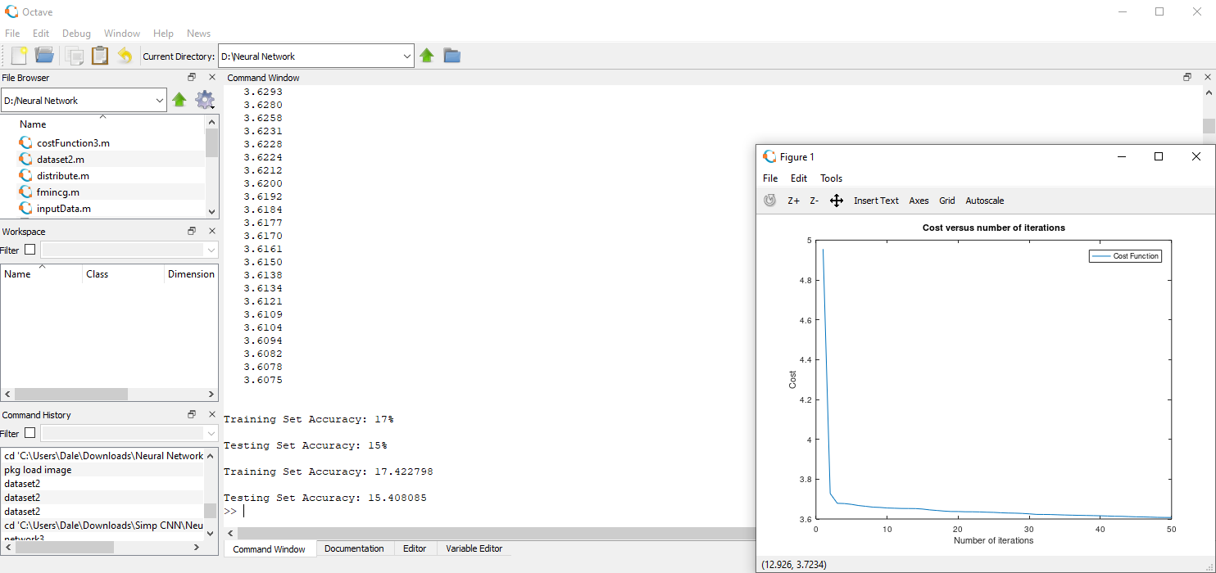

The image above shows the results of training a 3 layered network with 100 activation units in the second layer for 50 iterations achieves. In what appears to be the first 3 iterations the cost dramatically decreased. After this period, the decrease in cost quickly levelled out indicating the network could not be trained further. The success rate of the network on the test and training set were low but similar suggesting the network suffered from bias.

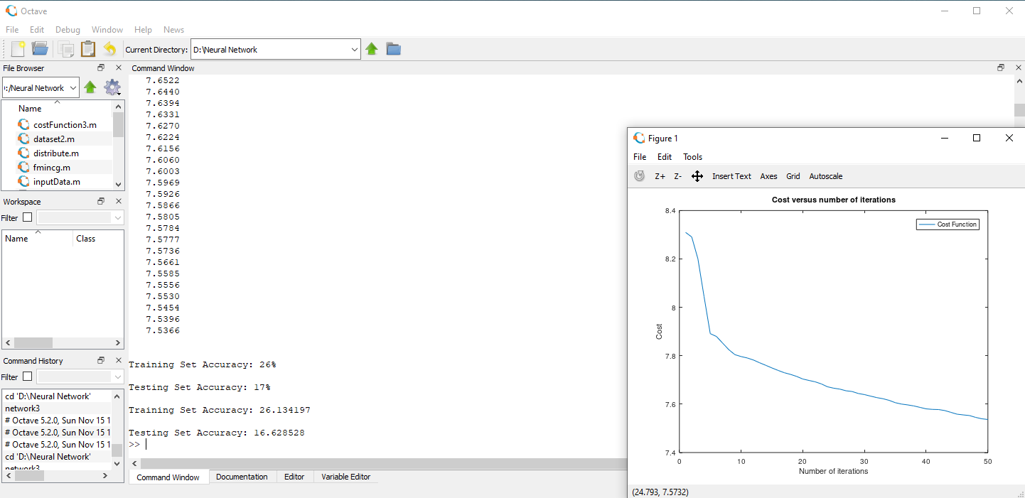

I altered the size of the hidden layer to consist of 1000 activation units. The graph indicates a steadier decrease in the cost with potential for the cost to decrease even further after 50 iterations. The success rate of predications made on the training set was almost 10% higher however the test set predictions only increased by a meagre 2%. This suggest the network was suffering from variance and severely overfitting the data.

Cost function (2 hidden layers)

function [J, grad] = costFunction4(unrl_params, ...

                                   input_layer_size, ...

                                   hidden_layer_size, ...

                                   hidden_layer2_size, ...

                                   X, Y, lambda)

  num_labels = size(Y, 2);

  #resize the vector of unrolled parameters to their original dimensions

  Theta1Size = hidden_layer_size * (input_layer_size + 1);

  Theta2Size = hidden_layer2_size * (hidden_layer_size + 1);

  Theta1 = reshape(unrl_params(1:Theta1Size), hidden_layer_size, (input_layer_size + 1));

  Theta2 = reshape(unrl_params(1 + Theta1Size:(Theta1Size + Theta2Size)), ...

                   hidden_layer2_size, (hidden_layer_size + 1));

  Theta3 = reshape(unrl_params(1 + Theta1Size + Theta2Size:end), ...

                   num_labels, (hidden_layer2_size + 1));

  m = size(X, 1);

  J = 0;

  #Vectorised forward propagation:

  #=> forward propogation for all examples executed simulataneously

  a0 = [ones(m,1), X];

  z1 = a0 * Theta1';

  a1 = sigmoid(z1);

  a1 = [ones(m,1), a1];

  z2 = a1 * Theta2';

  a2 = sigmoid(z2);

  a2 = [ones(m,1), a2];

  z3 = a2 * Theta3';

  a3 = sigmoid(z3);

  #Cost function:

  #J = 1/m(-y*log(h*x) - (1-y)log(1-h*x)) + (lambda/2m)(theta1^2+ theta2^2)

  #J = 1/m(-y*log(h*x) - (1-y)log(1-h*x))

  J = sum(sum( -Y.*log(a3) - (1-Y).*log(1-a3) ))/m;

  #Add the regularisation penalty

  #J = J +  (lambda/2m)(theta1^2+ theta2^2)

  J = J + (sum(sum(Theta1(:,2:end).^2)) + sum(sum(Theta2(:,2:end).^2)) + sum(sum(Theta3(:,2:end).^2 )))* lambda/(2*m);

  ##Here onwards is for calculating the partial derivatives of the cost function

  Theta1_grad = zeros(size(Theta1));

  Theta2_grad = zeros(size(Theta2));

  Theta3_grad = zeros(size(Theta3));

  #sample by sample

  for i = 1:m

    #Forward propagate

    a_0 = X(i, :)';

    a_0 = [1; a_0];

    z_1 = Theta1 * a_0;

    a_1 = sigmoid(z_1);

    a_1 = [1; a_1];

    z_2 = Theta2 * a_1;

    a_2 = sigmoid(z_2);

    a_2 = [1; a_2];

    z_3 = Theta3 *a_2;

    a_3 = sigmoid(z_3);

    #Error

    Ycurrent = Y(i, :)';

    delta_3 = a_3 - Ycurrent;

    #Propogate error backwards

    delta_2 = (Theta3' * delta_3).* sigmoidGradient([1; z_2]);

    delta_2 = delta_2(2:end);

    delta_1 = (Theta2' * delta_2).* sigmoidGradient([1; z_1]);

    delta_1 = delta_1(2:end);

    dt3 = delta_3 * a_2';

    dt2 = delta_2 * a_1';

    dt1 = delta_1 * a_0';

    #The deltas are the error in the activation units

    #The dts are the partial derivats of the cost function/error in parameters

    #The partial derivatives of each training example are added to the partial

    #derivatives of their previous example

    Theta3_grad = Theta3_grad + dt3;

    Theta2_grad = Theta2_grad + dt2;

    Theta1_grad = Theta1_grad + dt1;

  end;

  #divide by the number of training examples to get the average of the partial derivatives

  Theta1_grad = (1/m) * Theta1_grad;

  Theta2_grad = (1/m) * Theta2_grad;

  Theta3_grad = (1/m) * Theta3_grad;

  #Add the regularisation terms

  Theta1_grad(:,2:end) = Theta1_grad(:,2:end) + (lambda/m) * Theta1(:,2:end);

  Theta2_grad(:,2:end) = Theta2_grad(:,2:end) + (lambda/m) * Theta2(:,2:end);

  Theta3_grad(:,2:end) = Theta3_grad(:,2:end) + (lambda/m) * Theta3(:,2:end);

  #Similar to the regularisation in the cost function, ignore the bias units

  #because they have no impact on the regularisation

  #grad is the unrolled vector of the the cost function partial derivatives

  grad = [Theta1_grad(:); Theta2_grad(:); Theta3_grad(:)];

endfunction

Predict function (2 hidden layers)

function p = predict(Theta1, Theta2, Theta3, X)

  #m is the number of samples

  m = size(X, 1);

  p = zeros(m, 1);

  #forward propogate throught the network

  h1 = sigmoid([ones(m, 1) X] * Theta1');

  h2 = sigmoid([ones(m, 1) h1] * Theta2');

  h3 = sigmoid([ones(m, 1) h2] * Theta3');

  #finds the indexes of the the maximum values of h2 and returns

  #them in the output vector p

  [dummy, p] = max(h3, [], 2);

  #What it does is find the integer label of the node with highest probability

  #in a sample

  #It does this for all the samples until it has an m*1 vector of integer labels

endfunction

Network training function (2 hidden layers)

function network4

  #read the data

  ordered = dlmread("mushroomdata2.txt");

  #Shuffle and split the data into training and test data

  [trainData, testData] = distribute(ordered);

  #Seperate the training and test data into input and output data

  [X1,Y1,labels1] = inputData(trainData);

  [X2,Y2,labels2] = inputData(testData);

  #Creating the dimensions of the network

  xSize = size(X1, 2);

  a1Size = 1000;

  a2Size = 1000;

  ySize = size(Y1, 2);

  #randomly generating the parameters

  h = @randInitialiseWeights;

  initial_Theta1 = h(xSize, a1Size);

  initial_Theta2 = h(a1Size, a2Size);

  initial_Theta3 = h(a2Size, ySize);

  #Setting variables for use in fmincg

  initial_unrl_params = [initial_Theta1(:); initial_Theta2(:); initial_Theta3(:)];

  lambda = 1;

  options = optimset('MaxIter', 50);

  #create "short hand" for the cost function to be minimized

  costF = @(p) costFunction4(p, xSize, a1Size, a2Size, X1, Y1, lambda);

  [unrl_params, cost] = fmincg(costF, initial_unrl_params, options);

  fprintf('The costs values');

  cost

  plot(cost);

  title('Cost versus number of iterations');

  xlabel('Number of iterations');

  ylabel('Cost');

  legend('Cost Function');

  #reshaping the unrolled recalculated parameters into their original dimensions

  Theta1Size = a1Size * (xSize+1);

  Theta2Size = a2Size * (a1Size+1);

  Theta1 = reshape(unrl_params(1:Theta1Size), a1Size, (xSize+1));

  Theta2 = reshape(unrl_params(1 + Theta1Size:(Theta1Size + Theta2Size)), a2Size, (a1Size+1));

  Theta3 = reshape(unrl_params(1 + Theta1Size + Theta2Size:end), ySize, (a2Size+1));

  #Get the predicted values of the network with the recalculated parameters

  #for the training and test data

  pred1 = predict(Theta1, Theta2, Theta3, X1);

  pred2 = predict(Theta1, Theta2, Theta3, X2);

  #These for loops track how many of the networks predictions are right in

  #the sum variables

  sum1 = 0;

  sum2 = 0;

  for i = 1:length(pred1)

    if pred1(i) == labels1(i)

      sum1 += 1;

    end

  end

  for i = 1:length(pred2)

    if pred2(i) == labels2(i)

      sum2 += 1;

    end

  end

  #The % accuracy of the network on the training and test data are calculated

  accuracy1 = sum1/length(pred1) * 100;

  accuracy2 = sum2/length(pred2) * 100;

  #the %.f is the format function which maps the value I give into the string

  #the %% is actually just % in the printed output

  #the \n creates a new line

  fprintf("\nTraining Set Accuracy: %.f%%\n", accuracy1);

  fprintf("\nTesting Set Accuracy: %.f%%\n", accuracy2);

  #alternate method of displaying accuracy

  fprintf('\nTraining Set Accuracy: %f\n', mean(double(pred1 == labels1)) * 100);

  fprintf('\nTesting Set Accuracy: %f\n', mean(double(pred2 == labels2)) * 100);

endfunction

4 layered network analysis

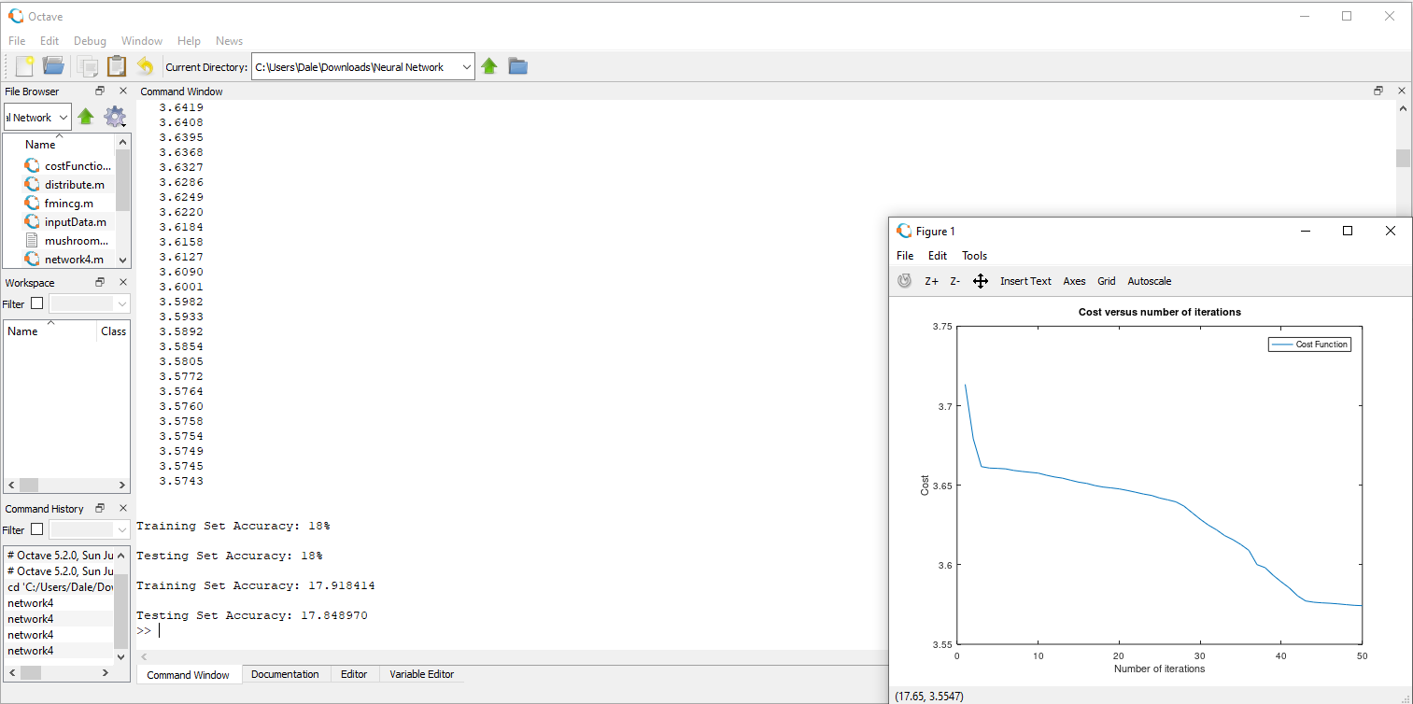

This network was built with 2 hidden layers with 100 activation units within each one. As expected, the cost decreases but the shape of the graph is very different from the other tests. The initial drop plateaus at 4 iterations but surprisingly there is another drop (less step than the first) at around 30 iterations. The Accuracy is higher than that of the 3 layered network with 100 activation units but it is still low. The values for the test and training predictions are approximately the same so the bias-variance trade-off is balanced, this means I am neither overfitting nor underfitting the data so the complexity of the network is fine.

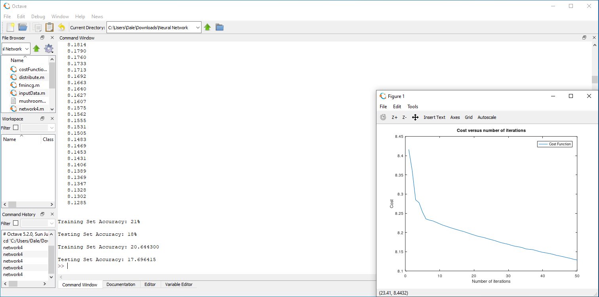

I increased the dimensions of the hidden layers by a factor of 10 – so each hidden layer had 1000 activation units. The minimisation of the cost is more constant/standard compared to the previous test. Despite accuracy of the test set increasing by 3% the testing set accuracy was invariant. This suggests the model was suffering from variance and overfitted the data. Therein it is clear having a 2-layer network with 1000 activation units in each layer is not necessary.

Conclusion and comments for the training network

To decide on the dimensions of the final neural network I carried out four different investigations. The first pair of investigations focused on building two 3 layered networks, one with 100 activation units and the other with 1000 activation units. Upon training the networks over 50 cycles I preferred the results of the network with fewer activation units. Despite having a lower average success rate with its predictions, the results of the test set and training set were similar. A network suffering from bias is easier to improve than a network held back by variance. Bias be greatly reduced by improving the dataset I train the network on.

The other pair of networks had 4 layers. For simplicity I decided for both networks to have the same number of activation units in both of their hidden layers; one network had 100 activation units in both its hidden layers and the other had 1000 activation units. Neither network suffered a lot from variance but the network with more units certainly had a larger disparity between its predictions on the test set vs training set compared to the simpler network. The menial difference and higher variance of the more complex network suggest increasing the number of activation units to 1000 units to be unnecessary.

Comparing the victors of both pairs I believe the 4 layered network has the upper hand as its success rate of prediction are an improved version of the 3 layered network’s predictions. In addition, since the difference between results of the 4 and 3 layered networks was menial, I suspect increasing the number of layers further will other provide little improvement in making successful predictions and most likely lead to the network overfitting data. As for the poor success rate of predictions, I believe the dataset is at fault. As shown by the tests when I altered features of the network its success rate improved so its logic is not the issue. Only by expanding the dataset can I ensure the probabilities will continue to rise.

Stage3: Building the application (Python)

Implementing the neural network

import numpy as np

from PIL import Image

import os

import warnings

def Network(file_location):

    #sigmoid function

    def sigmoid(x):

        return 1/(1+np.exp(-x))

    #converts the file location of the given image into usable data

    def dataConvert(image):

        image = Image.open(file_location, 'r')

        image = image.convert('L') ## makes image grayscale

        data = np.asarray(image)

        resized = np.resize(data,(100,100))

        input_data = np.reshape(resized,(10000,1))

        return input_data

    #the image is forward propagated along the network

    #it uses the parameters in the csv files which was created by the trained  network

    def forwardProp(input_layer, Theta1, Theta2):

        one = np.array([[1]])

        a0 = np.append(one, input_layer, axis=0)

        z1 = Theta1.dot(a0)

        a1 = np.array([sigmoid(xi) for xi in z1])

        a1 = np.append(one, a1, axis=0)

        z2 = Theta2.dot(a1)

        a2 = np.array([sigmoid(xi) for xi in z2])

        return a2

    def predict(output):

        MaxElement = np.amax(output)

        position = np.where(output == MaxElement)

        mushroom = int(position[0]-1)

        return mushroom

    #A tuple stores the names of my mushroom species with a fixed index

    fungi =('Amanita muscaria','Cantharellus cibarius','Flammulina velutipes'\

        'Agaricus campestris','Grifola frondosa','Craterellus cornucopioides'\

        'Morchella elata', 'Pleurotus ostreatus', 'Boletus edulis', 'Lentinula edodes')

    #changing the default directory

    os.chdir("C:/users/Dale/Downloads/Python CNN")

    #to ignore the overflow warning in the exp function *used in the sigmoid  function

    warnings.filterwarnings("ignore")

    #file_location = input("File location of your image: ")

    #Loading the precalculated parameters

    Theta1 = np.loadtxt("paramsLayer1.csv", delimiter=",")

    Theta2 = np.loadtxt("paramsLayer2.csv", delimiter=",")

    #loading the input data

    #applying the neural network to the data

    input_layer = dataConvert(file_location)

    output = forwardProp(input_layer, Theta1, Theta2)

    prediction = predict(output)

    prediction = fungi[prediction]

    #displaying the prediction

    #print(prediction)

    return prediction

#This codes for my most basic Neural Network with 1 hidden layer of 100 units

Species classifier

class species():

    def __init__(self, latinName, commonName, family, edibility, location, season, features):

        self.latinName = latinName

        self.commonName = commonName

        self.family = family

        self.edibility = edibility

        self.location = location

        self.season = season

        self.features = features

#This will be the class which allows me to create new infomation for my mushrooms quickly in the database

Database builder/editor

import sqlite3

from species_classifier import species

import Neural_Network

conn = sqlite3.connect('fungidata.db')

c = conn.cursor()

c.execute("""CREATE TABLE IF NOT EXISTS attributes (

            latinName text PRIMARY KEY,

            commonName text,

            family text,

            edibility text,

            location text,

            season text,

            features text

            )""");

conn.commit()

#def insert_traits(*args):

#   for arg in args:

#       c.execute("INSERT INTO attributes VALUES (:latinName, :commonName, :family, :edibility, :location, :season, :features)",

#           {'latinName': arg.latinName, 'commonName': arg.commonName, 'family': arg.family, 'edibility': arg.edibility,

#            'location': arg.location, 'season': arg.season, 'features': arg.features});

#       conn.commit()

Species1 = species('Amanita muscaria','Fly Agaric','Pluteaceae','poisonous: hallucinogenic',

                    'North America, Europe, Asia', 'all year',

                    'hollow white stem, convex red/orange cap, scale-like patches, white gills')

Species2 = species('Cantharellus cibarius','Chanterelle','Cantharellaceae','edible: delicious',

                    'North America, Europe', 'May-November',

                    'solid stem, tough concave cap, gills, body is bright yellow/orange')

Species3 = species('Flammulina velutipes','Enokitake','Physalacriaceae','edible: tasty',

                    'Asia', 'all year',

                    'long thin white stem, tiny cap, grows in clusters')

Species4 = species('Agaricus campestris','Field mushroom','Agaricaceae','edible: tasty',

                    'all regions', 'all year',

                    'solid white stem, flacky convex cap, brown gills')

Species5 = species('Grifola frondosa','Hen of the Woods','Meripilaceae','edible: delicious',

                    'North America, Europe', 'August-November',

                    'brown/grey body with a light underside, grows in clusters')

Species6 = species('Craterellus cornucopioides','Horn of Plenty','Cantharellaceae','edible: delicious',

                    'North America, Europe', 'August-October',

                    'hollow trumpet like body with a grey underside and black top, grows in clusters')

Species7 = species('Morchella elata','Black Morel','Morchellaceae','edible: delicious',

                    'North America, Europe', 'April-June',

                    'hollow short stem, oblong cone shaped wrinkled cap')

Species8 = species('Pleurotus ostreatus','Oyster','Pleurotaceae','edible: tasty',

                    'all regions', 'June-September',

                    'grey/light grey top, white gills, grow in clusters')

Species9 = species('Boletus edulis','Porcini/Penny Bun','Boletaceae','edible: delicious',

                    'North America, Europe, East Asia', 'August-October',

                    'bulbous white stem, chestnut coloured cap, spongy underside')

Species10 = species('Lentinula edodes','Shiitake','Marasmiaceae','edible: tasty',

                    'Asia', 'all year',

                    'white stem, light/dark brown flacky convex cap, light gills')

#insert_traits(Species1, Species2, Species3, Species4, Species5, Species6, Species7, Species8, Species9, Species10);

#c.execute("SELECT * FROM attributes")

#rows = c.fetchall()

#print(rows)

#This was just a test for extracting data based on predictions from the neural network

c.execute("SELECT * FROM attributes WHERE latinName = '{}'".format(Neural_Network.prediction))

print(c.fetchall())

conn.close()

I decided to build the database as a single table because I had only included 10 mushrooms and most of them had little in common. Had I started with 1000s of mushrooms then I would have made a relation database like I originally planned. In addition, as explained earlier adding even one mushroom specie to the database takes hours of work just from a manual labour point of view. The only way I could significantly speed of the process of getting reliable mushroom images would be to code a an unsupervised for grouping web scraped images, and even then the algorithm would have to be built incredibly well and I would still need to assess the data groups and assign them specie names. I could additionally expand my searches to other search engines as well as websites with those search engines. This would take further research for me to implement as I do not yet have the skills for this.

Graphical user interface

#Import the essentials to run the application

#Note that I don't need to import layouts because all the GUI design happens in the kv file which automatically loads all formats

#This py file handles all the logic of the application

from kivy.app import App

from kivy.lang import Builder

from kivy.uix.screenmanager import ScreenManager, Screen

from kivy.uix.boxlayout import BoxLayout

from kivy.uix.gridlayout import GridLayout

from kivy.uix.boxlayout import BoxLayout

from kivy.uix.image import Image

from kivy.properties import ObjectProperty

from kivy.uix.popup import Popup

from kivy.uix.label import Label

from kivy.uix.button import Button

import Neural_Network

import sqlite3

import os.path

#initialise a connection between the database and the program

conn = sqlite3.connect('fungidata.db')

c = conn.cursor()

#This class builds the main menu of the application

class MainWindow(Screen):

    #If the contact button is selected, a pop up window with contact information will apppear

    def call_ContactPopUp(self):

        self.contact_popup = show_contact_popup()

    def call_InProgressPopUp(self):

        self.inprogress_popup = show_in_progress_popup()

#This class defines the window where the user specifies the mushroom they want to identify

class IdentifyWindow(Screen):

    image_location = ObjectProperty(None)

    def networkLink(self, root_manager):

        file_location = self.image_location.text

        speciesName = Neural_Network.Network(file_location)

        c.execute("SELECT * FROM attributes WHERE latinName = '{}'".format(speciesName))

        info = c.fetchall()

        #need this for loop so I can access the individual elements of info (which contains the information about the predicted mushroom)

        for item in info:

            row = item

        #change the values of the labels to the values of the predicted mushroom

        root_manager.info_scrn.latinName.text = 'Latin name: ' + str(row[0])

        root_manager.info_scrn.commonName.text = 'Common name: ' + str(row[1])

        root_manager.info_scrn.family.text = 'Family: ' + str(row[2])

        root_manager.info_scrn.edibility.text = 'Edibility: ' + str(row[3])

        root_manager.info_scrn.region.text = 'Found in: ' + str(row[4])

        root_manager.info_scrn.season.text = 'Foraging season: ' + str(row[5])

        root_manager.info_scrn.features.text = '' + str(row[6])

        #change the image of the button to an examplar image of the predicted mushroom

        root_manager.info_scrn.image.background_normal = 'Examplar Mushrooms/{}.jpg'.format(speciesName)

        root_manager.info_scrn.image.background_down = 'Examplar Mushrooms/{}.jpg'.format(speciesName)

        root_manager.info_scrn.userImage.background_normal = '{}'.format(file_location)

        root_manager.info_scrn.userImage.background_down = '{}'.format(file_location)

    def fileChecker(self):

        return os.path.isfile(self.image_location.text)

    #This method calls the show_popup() function to create the pop up window

    def call_PopUp(self):

        self.popup = show_popup()

#Declaring a key as an object property allows me to alter and use its value in the kv file

#I did this for all the categories of information that are dependent on the prediction

class InformationWindow(Screen):

    latinName = ObjectProperty(None)

    commonName = ObjectProperty(None)

    family = ObjectProperty(None)

    edibility = ObjectProperty(None)

    region = ObjectProperty(None)

    season = ObjectProperty(None)

    features = ObjectProperty(None)

    #This method gets the latin name text from the third window and searches for more examplar images of the predicted species in the system

    #It then changes the images in the ImageWindow accordingly

    #I used the same technique here as I did when changing the values of the labels in the InformationWindow from IdentifyWindow

    def showImages(self, root_manager):

        latinName = root_manager.info_scrn.latinName.text

        speciesName = []

        i = 12                                          #i = 12 because that is the length of characters of 'Latin name: '

        while i>=12 and i<len(latinName):               #I only want the species name itself, not the text before it

            speciesName.append(latinName[i])            #That is why I need to create a new string with only the species name

            i+=1                                        #I need to use the < symbol not the <= symbol because len records the length of the string indexed from 1

                                                        #but the list is is indexed from 0

        speciesName = ''.join(speciesName)

        root_manager.image_scrn.im1.source = 'More Mushroom Images/{}/1.jpg'.format(speciesName)

        root_manager.image_scrn.im2.source = 'More Mushroom Images/{}/2.jpg'.format(speciesName)

        root_manager.image_scrn.im3.source = 'More Mushroom Images/{}/3.jpg'.format(speciesName)

        root_manager.image_scrn.im4.source = 'More Mushroom Images/{}/4.jpg'.format(speciesName)

#This class loads in the stored example images into a window for the users to see

class ImageWindow(Screen):

    im1 = ObjectProperty(None)

    im2 = ObjectProperty(None)

    im3 = ObjectProperty(None)

    im4 = ObjectProperty(None)

#This window is still in heavy development

class EncyclopediaWindow(Screen):

    #not working, just the grid layout bit, don't know why

    def __init__(self, **kwargs):

        super(EncyclopediaWindow, self).__init__(**kwargs)

        c.execute('SELECT * FROM attributes')

        data = c.fetchall()

        k = 0

        latinName, commonName, family, edibility, region, season, features = [],[],[],[],[],[],[]

        while k < len(data):

            latinName.append(data[k][0])

            commonName.append(data[k][1])

            family.append(data[k][2])

            edibility.append(data[k][3])

            region.append(data[k][4])

            season.append(data[k][5])

            features.append(data[k][6])

            k+=1

        #issue lies with the grid layout section

        self.grid = BoxLayout(orientation= 'vertical')

        self.grid.cols = 2

        self.grid.add_widget(Button(text='test', size_hint_x=None, width=100))

        self.grid.add_widget(Button(text='test'))

        self.grid.add_widget(Button(text='test', size_hint_x=None, width=100))

        self.grid.add_widget(Button(text='test'))

        i=0

        while i < len(data):

            self.grid.add_widget(Image(source='C:/Users/Dale/Downloads/Python CNN/Examplar Mushrooms/{}'.format(latinName[i])))

            self.grid.add_widget(Button(text='{}'.format(commonName[i]), font_size=40))

            i+=1

#Assigning this key as an object property allows me to use and change objects from the InformationWindow and ImageWindow from other windows

class WindowManager(ScreenManager):

    info_scrn = ObjectProperty(None)

    image_scrn = ObjectProperty(None)

#This class creates the design for the popup window

class PopUp_Layout(BoxLayout):

    pass

class ContactPopUp_Layout(BoxLayout):

    pass

class InProgressPopUp_Layout(BoxLayout):

    pass

#This function creates the pop up window by creating an instance of the PopUp class and calling the Popup function from kivy

def show_popup():

    show = PopUp_Layout()

    popupWindow = Popup(title='Location Error', content=show, size_hint=(None,None), size=(400,400))

    popupWindow.open()

    return popupWindow

    #return a reference of the popup (this will by saved to the instance created in call_PopUp)

#This popup window is for the instance when the contact button is selected

def show_contact_popup():

    show = ContactPopUp_Layout()

    popupWindow = Popup(title='Contact Information', content=show, size_hint=(None,None), size=(420,300))

    popupWindow.open()

    return popupWindow

#This popup window will be called if there is a feature that is still being built in the app

def show_in_progress_popup():

    show =InProgressPopUp_Layout()

    popupWindow = Popup(title='In Progress', content=show, size_hint=(None,None), size=(420,300))

    popupWindow.open()

    return popupWindow

#Directly call the kv file which links to the classes of this file and builds the GUI of the program

kv = Builder.load_file('GUI-version2.kv')

#This class builds the application

class Identify_Fungi(App):

    def build(self):

        return WindowManager()

#If this file is the file being run, and not imported then run the application

if __name__ == '__main__':

    Identify_Fungi().run()

Kivy language file

 <WindowManager>:

    info_scrn: info_screen

    image_scrn: image_screen

    enc_scrn: encyclopedia_screen

    MainWindow:

    IdentifyWindow:

    InformationWindow:

        id: info_screen

    #I have to add these id's if I want to share information produced by widgets between the different classes/windows

    ImageWindow:

        id: image_screen

    EncyclopediaWindow:

        id: encyclopedia_screen

#This window is the menu which allows the user to branch to the features they want to use

<MainWindow>:

    name: 'menu'

    canvas:

        Rectangle:

            source: 'background4.jpg'

            pos: self.pos

            size: self.size

    BoxLayout:

        orientation: 'vertical'

        padding: 200

        Button:

            text: 'Identify'

            on_release:

                app.root.current = 'identify'

                root.manager.transition.direction = 'left'

        Button:

            text: 'Encyclopedia'

            on_release:

                root.call_InProgressPopUp()

        Button:

            text: 'Calendar'

            on_release:

                root.call_InProgressPopUp()

        Button:

            text: 'Contact'

            on_release:

                root.call_ContactPopUp()

#This window is where the user identifies their mushroom

<IdentifyWindow>:

    name: 'identify'

    image_location: location

    canvas:

        Rectangle:

            source: 'background4.jpg'

            pos: self.pos

            size: self.size

    BoxLayout:

        orientation: 'vertical'

        padding:200, 200, 200, 200

        pos_hint: {'x':0, 'y':0.1}

        #padding: [padding_left, padding_top, padding_right, padding_bottom]

        #needed to shift the layout up a little bit to centre it

        BoxLayout:

            orientation: 'horizontal'

            Label:

                text: 'File Location: '

                size_hint_y:0.4

                #These size hints change the size of the widgets inside the box layouts proportionally

            TextInput:

                id: location

                multiline: False

                font_size: 20

                size_hint_x: 2.5

                size_hint_y: 0.4

        BoxLayout:

            orientation: 'horizontal'

            Button:

                text: 'Back'

                size_hint_y: 0.6

                on_release:

                    app.root.current = 'menu'

                    root.manager.transition.direction = 'right'

            Button:

                text: 'Identify'

                size_hint_y: 0.6

                on_release:

                    if root.fileChecker() == True: \

                    root.networkLink(root.manager); \

                    app.root.current = 'species'

                    else: \

                    root.call_PopUp()

                    root.manager.transition.direction = 'left'

                #The statement above checks if the file location spefied by the user exists

                #if it doesn't exist then a pop up window explaining their error appears

                #if it exists, the neural network is executed and it moves onto the

                #next window which displays information about the predicted mushroom

                #also if statements look a little different in kv language

#This window contains all the inforamation of the predicted mushroom for the user to read

<InformationWindow>:

    name: 'species'

    latinName: LatinName

    commonName: CommonName

    family: Family

    edibility: Edibility

    region: Region

    season: Season

    features: Features

    image: mushroom_image

    userImage: user_image

    BoxLayout:

        orientation: 'vertical'

        BoxLayout:

            orientation: 'horizontal'

            BoxLayout:

                orientation: 'vertical'

                #this button is just an image of an examplar mushroom

                Button:

                    id: mushroom_image

                    text: ''

                    background_normal: ''

                    background_down: ''

                    #when released it runs a method which generates the images for the info window

                    #then it transistions onto the info window

                    on_release:

                        root.showImages(root.manager)

                        app.root.current = 'more_images'

                        root.manager.transition.direction = 'left'

                #Display the image the user inputted underneath the predicted mushroom image

                Button:

                    id: user_image

                    background_normal: ''

                    background_down: ''

            #Display the information about the predicted mushroom

            BoxLayout:

                orientation: 'vertical'

                spacing: 10

                padding: 10

                Label:

                    id: LatinName

                    text: 'Latin Name: '

                    font_size: 20

                    valign: 'middle'

                    text_size: self.size

                Label:

                    id: CommonName

                    text: 'Common Name: '

                    font_size: 20

                    valign: 'middle'

                    text_size: self.size

                Label:

                    id: Family

                    text: 'Family: '

                    font_size: 20

                    valign: 'middle'

                    text_size: self.size

                Label:

                    id: Edibility

                    text: 'Edibility: '

                    font_size: 20

                    valign: 'middle'

                    text_size: self.size

                Label:

                    id: Region

                    text: 'Found in: '

                    font_size: 20

                    valign: 'middle'

                    text_size: self.size

                Label:

                    id: Season

                    text: 'Foraging Season: '

                    font_size: 20

                    halign: 'left'

                    valign: 'middle'

                    text_size: self.size

                BoxLayout:

                    orientation: 'horizontal'

                    Label:

                        text: 'Key Features: '

                        font_size: 20

                        halign: 'left'

                        valign: 'middle'

                        text_size: self.size

                        size_hint_x: 0.6

                    Label:

                        id: Features

                        text: ''

                        font_size: 14

                        halign: 'left'

                        text_size: self.size

        #Back button to go to the previous window

        Button:

            text: 'Back'

            size_hint_y: 0.3

            on_release:

                app.root.current = 'identify'

                root.manager.transition.direction = 'right'

#This window displays 4 more images of the predicted mushroom for the user to look at

<ImageWindow>:

    name: 'more_images'

    im1: image1

    im2: image2

    im3: image3

    im4: image4

    #These box layouts generate a 2*2 grid with an image in each square

    BoxLayout:

        orientation: 'vertical'

        BoxLayout:

            orientation: 'horizontal'

            Image:

                id: image1

                source: 'More Mushroom Images/Amanita muscaria/1.jpg'

            Image:

                id: image2

                source: 'More Mushroom Images/Amanita muscaria/1.jpg'

        BoxLayout:

            orientation: 'horizontal'

            Image:

                id: image3

                source: 'More Mushroom Images/Amanita muscaria/1.jpg'

            Image:

                id: image4

                source: 'More Mushroom Images/Amanita muscaria/1.jpg'

        Button:

            text: 'Back'

            size_hint_y: 0.6

            on_release:

                app.root.current = 'species'

                root.manager.transition.direction = 'right'

#In progress

<EncyclopediaWindow>:

    name: 'encyclopedia'

#In progress

<CalanderWindow>:

    name: 'calander'

#The class designs the layout for the pop up window for the IdenifyWindow

<PopUp_Layout>:

    BoxLayout:

        orientation: 'vertical'

        Label:

            text: "The file location you have chosen doesn't exist"

        Label:

            text: "Example: C:/Users/David/Downloads/image.jpg"

        Label:

            text: ''

            size_hint_y: 1.4

<ContactPopUp_Layout>:

    BoxLayout:

        orientation: 'vertical'

        Label:

            text: "Email: benjamin.banks960@gmail.com"

<InProgressPopUp_Layout>:

    BoxLayout:

        orientation: 'vertical'

        Label:

            text: "The feature you selected is currently unavailable"

The application in view

The main menu

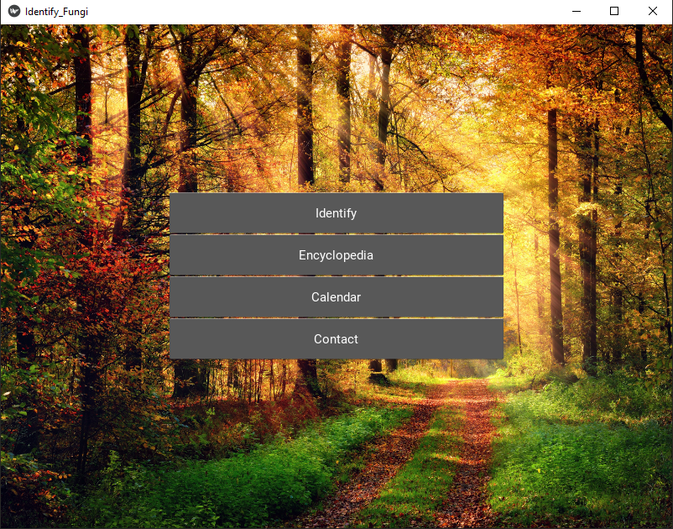

Description:

When you run the application, this is the first window that will appear. There are four options for the user to choose from, however two of the options are still under development. If the user clicks either the Encyclopaedia or Calendar button then a popup window explaining that they are incomplete should appear. A popup window will also appear if the user presses the Contact button but its contents will display my contact information. If the user selects the identify widget then the program will smoothly transition to a new window known as the identification window.

The identification window

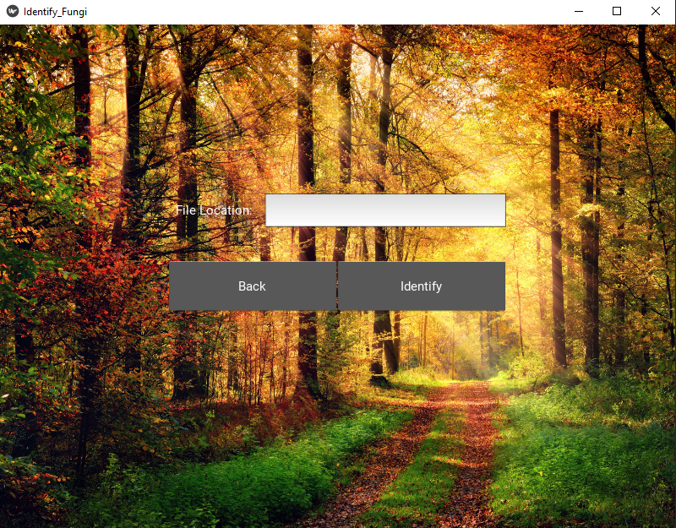

Description:

This window allows the user to type the file location of the image they want to the application to analyse. If the string of characters they enter successfully match the path of an image file and they press the identify button then the program will parse the image along the trained neural network and smoothly transition to the information window. However, if the path that the user typed does not exist, then a popup window will appear; it will tell the user their error an give a formatted example of what the file path of an image should look like. I originally planned for the user to able to search their files and select the image file graphically but I found it too troublesome to implement in Kivy.

The information window

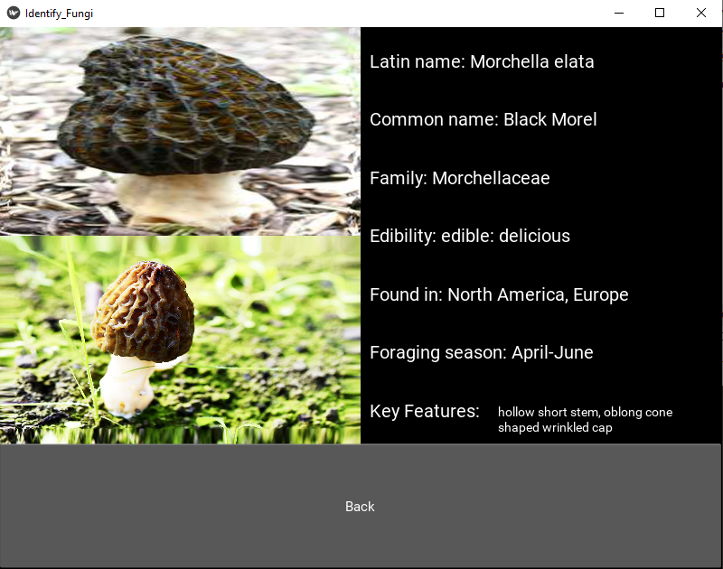

Description:

The information window is based on the prediction made by the neural network. Information on the predicted mushroom is taken from the mushroom database and displayed on the righthand side of the window. Ignoring the back button, the bottom left corner contains the image the user submitted – I thought this would make comparing the submitted and predicted mushroom easier for the user. In the top left corner, there is an exemplar image of the predicted mushroom. It is also a widget which smoothly transitions the window to the image window when selected.

The image window

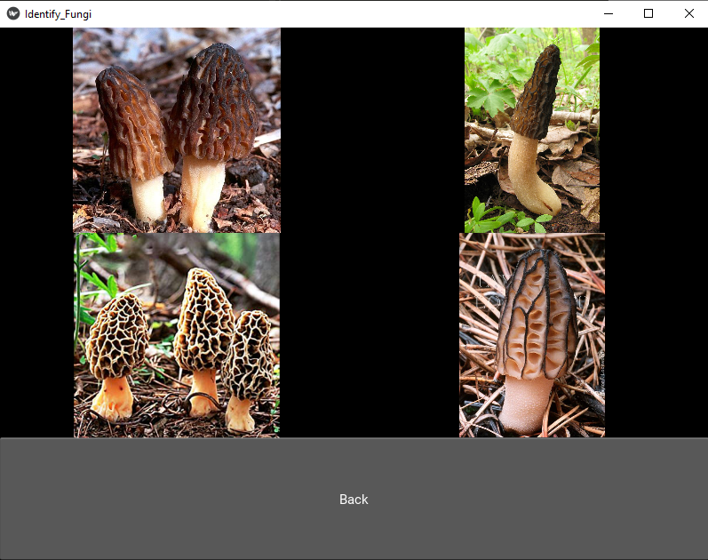

Description:

The image window displays four more images of the same mushroom species as reference images for the user, in case the previous exemplar was not enough proof for the validity of the prediction.

# Testing

Test Results

|  |  |  |  |  |
| --- | --- | --- | --- | --- |
| No | Test | Timestamp | Outcome | Result |
| 1. | Click each widget at least once. | 0:00 – 2:35 | All the widgets functioned as they were supposed to. | Success |
| 2. | Type a file location in the text box which does not exist. | 0:17 – 0:28 | A pop-up window explaining the location they entered was incorrect appeared. | Success |
| 3. | Attempt to use an SQL injection in the text box. | 0:30 – 0:41 | A pop-up window explaining the location they entered was incorrect appeared. | Success |
| 4. | Use ‘\’ instead of ‘/’ when typing the file location. | 0:50 – 1:20 | It recognised the location of the file without problems and processed the image without issues. | Success |
| 5. | Give the application an image of a mushroom that I know is on the database. | 0:50 – 1:05 | The application identified the image and produced the information window. | Success |
| 6. | Give the program images with different aspect ratios. | 1:16 – 2:18 | All the images were processed in the same manor giving results in the same format. | Success |
| 7. | Give the application an image which is not a mushroom. | 1:58 – 2:18 | It treated the image the same as that of a mushroom and produced a standard result of a mushroom it thought it was most like. | N/A |
| 8. | Give the application a corrupted image. | 2:22 – 2:35 | Instead of trying to process the error the app closed in reaction. | Success |
| 9. | Give the program the file location of a file that is not an image file, e.g. a document. |  | Instead of trying to process the error the app closed in reaction. | Success |
| 10. | Type the path of images with different file formats into the text box. | 1:28 – 2:18 | The CNN will operate the same for each format and make the best predictions it can. | Success |

Testing Video Link:

https://www.youtube.com/watch?v=uZui2NkCciw&feature=youtu.be

# Evaluation

Neural Network Objectives Redone with page numbers inserted

|  |  |  |  |  |
| --- | --- | --- | --- | --- |
| Objectives achieved | | Pg No | Objectives failed | |
| 1 | Scrape images from google with minimal mistakes. | 37-41 | 5 | Achieve a 90% success rate in making predictions. |
| 2 | Convert images into usable data. | 42-45 |  |  |
| 3 | The network’s dimensions are easy to change. | 57-58 |  |  |
| 4 | The network minimises its parameters. | 53,59 |  |  |
| 6 | The network is implemented in python and integrated within the GUI. | 61-77 |  |  |

Application Objectives Redone with page numbers inserted

|  |  |  |  |  |
| --- | --- | --- | --- | --- |
| Objectives achieved | | Pg No | Objectives failed | |
| 1 | A main menu displaying the four primary widgets and an exit button. | 78 | 4 | Once the user’s mushroom is identified, a list of the three most probable species is displayed. |
| 2 | The user can type the file location of their mushroom for identification. | 79 | 10 | Information about all the mushrooms in the system is accessible via the encyclopaedia. |
| 3 | The application identifies an image under 5 seconds. | 82 | 11 | A calendar displays the seasonality of mushrooms in alphabetical order. |
| 5 | Additional information appears under the identified mushroom. | 80 |  |  |
| 6 | More images appear if the image of the identified mushroom is selected. | 81 |  |  |
| 7 | A back button is present in all windows. | 79-81 |  |  |
| 8 | The transitions between windows is smooth and quick. | 82 |  |  |
| 9 | The application operates without connections to the internet. | 82 |  |  |
| 12 | A contact window displays my contact information. | 82 |  |  |

Interview with a prospective user

What is your opinion of the layout of the windows?

“Generally, I liked the layout. The positions of the buttons on the windows seemed natural and size wise they were neither too small nor jarring. “

Do you like the style of the widgets?

“They remind me of the buttons in the Minecraft menu but modernised which I quite like.”

What do you think of the transitions between windows?

“It seems natural how they slide left when back tracking in the application but slide right when you open a new window.”

Do you find the pop-up windows helpful?

“I wouldn’t have known how to enter the filenames without the pop window’s example.”

Are you satisfied with the information displayed about the mushrooms?

“I think the app includes all the key bit of information on the mushrooms, less important information like the mushroom’s rareness and history are not necessary in my opinion.”

Is there anything you particularly liked about the application?

“I really liked the autumnal feel of the main screen background.”

Do you have any extra comments about the software?

“The number of mushrooms the app can identify is limited, so I would love there the to be more mushrooms available for identification.”

When I chose my project, I decided to rely as little as possible on other people’s resources, whether this be datasets, functions or scripts. This elevated the difficulty of the task and made me encounter countless issues which I did not anticipate. My first problem faced was understanding the mechanisms behind the functionality of convolutional neural networks. What I originally thought would take at most 2 months took me nearly 6 months to fully grasp and implement. There were many little algorithms which I needed to have an in depth understanding of before I could attempt coding them. Tutorials and courses guided me through building these algorithms for the specific uses they intended, however if I wanted to use their algorithms, I would need to redesign and tailor them to my needs.

The learning curve of understanding neural networks to building them was steep, however there was a process which I had to focus on even before this. My first challenge was gathering the massive amount of data I would need to train the network. The script I used for scraping the images worked seamlessly but the process of gathering images was extremely slow and tiring. Each mushroom species required my to scroll to the bottom of the google image search for that mushroom, run the script, download the images to a dedicated folder, process them in Visipics to remove image duplicates, search in File Explorer to delete corrupt images and then manually sort through all the data to remove images which I knew were not part of the mushroom species I had searched. After applying all these filters, the original 700 images I had downloaded would be reduced to couple hundred. Even then, there would occasionally be hidden corrupt images within the dataset, which would require me to do another sweep to locate the issues. Each species also required me to search the name in different languages to increase the variety of my results; the process of filtering and sweeping through images would be repeated for each search. The slow monotonous nature of gathering data resulted in me only being able to gather enough data on 10 mushroom species. In addition, the number of images allocated to each species was uneven because certain search results produced fewer valid image matches. I wanted to create a more expansive dataset, but I had my limitations as gathering the images was a very time-consuming and draining process.

The number of images I collected totalled over 7000 which was sufficient for training a network but not enough for consistent results. Upon implemented an image augmentation script in python, I managed to increase the number of different images 10-fold. My next largest hurdle was creating the algorithm which transformed my collection of images into usable data. My initial version worked for jpg files but not for any other image formats. This led me to redesign the whole function so it could handle these exceptions. I found this coding process especially challenging because there were no examples online on how to approach this problem. I eventually overcame the issue by receiving feedback from a user on the MATLAB forum who suggested the problem I needed to solve.

For building the actual network, the algorithms I used had the capabilities to adapt to networks with different dimensions, however the versions I created while learning from external sources were geared towards to networks with only one hidden layer. Creating the first neural network with one hidden was still very difficult as I had to tailor the algorithms to the data I was processing but the process of redesigning the algorithms for my needs was manageable. In comparison, to build a network with 2 hidden layers I needed to redesign the algorithms again and since they were not originally intended to be expanded, it took a considerable amount of time and energy to successfully implement them. When I was redesigning the algorithms for a second time, I made them more modular to make the process of adding additional layers easier. This became redundant after I decided to stop increasing the number of hidden layers after 2 layers but at the time, I wasn’t sure how many layers the network would need before it was optimised.

Training the networks was another time-consuming task. I trained a total of 8 different networks; 4 of the networks trained on the original images (7000 in total) while the other networks trained on the augmented images (70000 in total). Each group were trained over 50 iterations – after carrying out several pre-tests I found this was the ideal number of epochs to use. The time taken to train the networks varied greatly; of course, the training time increased with the network’s complexity but the quantity of input data was the largest factor which impacted the training times. The group which trained on the original data took at most 1 hour to fully train whereas the group which trained on the augmented the data took up to a day to complete the 50 epochs. Surprisingly, the difference in success rates between the two groups’ predictions was marginal. The small improvements were still a benefit to the network, however the time-consuming nature of training the networks and indication that a network with more than 2 hidden layers might suffer from variance discouraged me from continuing to increase the dimensions of the networks. I decided on using a network with 2 hidden layers and 100 activation units in each layer as this option gave the most optimistic results.

Implementing the network in python was a simple process compared to training the network. I only needed to code the forward propagation algorithm and I encountered no issues when importing the trained parameters from the csv files. Creating the database used some of my time but compared to gathering the data it was only a matter of days. The difficulties in building the application lied with designing the GUI. Kivy had an amazing variety of widgets and formats to choose from, however learning the process of implementing them was difficult. Their documentation only covered general topics and did not focus on explaining many of the specific functions the library offered. I had to do a lot of external research to familiarise myself with library. Despite the learning steep learning curve of the library, I felt that the Kivy styling language simplified the coding process of the application. I was easily able to separate the functionality and style of the interface as well as link them together when needed.

Despite the success rate of predictions being underwhelming, I am satisfied with meeting the rest of the neural network objectives. The various tests I carried out heavily suggest that the network’s low success rate was not the fault of the network, but the images. I am sure that with better training data the network would excel. The only way I could significantly improve the network would be to rebuild it so it analysed the RGB colours in the images. I initially tried this, but I lacked the knowledge to elevate the network to work in 3 dimensions. In the future I will attempt building a 3-dimensional network to tackle the problem of identifying coloured images.

In terms of the functionality of the application I am satisfied with its current state. The process of identifying a mushroom is simple and self-explanatory. The information which is displayed together with the mushroom was extracted from the database without problems and the windows all had smooth transitions. The exemplar image may at times look distorted, this was an issue I could not easily resolve because the image was bound to a widget. It is a shame that I could not implement the calendar and encyclopaedia features in time, but these were only ever additional features and not a core function of the application, so they were not critical. In place of the windows they activated, the back-up pop-up windows I tied to them all operated as expected. I am pleased that using dictionaries when inserting records into the database paid off as a standard SQL injection was not able to penetrate the database. There are issues behind how the application reacts to corrupt and non-image files, but this is a menial problem as the application only closes and can be quickly restarted by the user.

To conclude, I encountered many issues when building the application. There are certainly improvements to be made but the overall functionality that I desired the application to have was achieved. The experience of designing to building the software was tiring at times but all in all I thoroughly enjoyed it and worked to the best of my abilities to create an application which successfully identifies different species of mushrooms.

# Bibliography

*App Grooves: The Mushroom Book*. (2020, 04 19). Retrieved from appgrooves.com: https://appgrooves.com/app/the-mushroom-book-pro-by-dominik-warszewski

*FREE! Mushroom Identification AI Assistant - Youtube*. (2020, 04 19). Retrieved from youtube.com: https://www.youtube.com/watch?v=7Xifk02FQGI&t=328s

Joe@EatThePlanet. (2020, 04 18). *Foraging Fatality Statistics 2016 - Eat The Planet*. Retrieved from eattheplanet.org: http://eattheplanet.org/foraging-fatality-statistics-2016/

Joe@EatThePlanet. (2020, 04 18). *How Many People Die Foraging Plants and Mushrooms in The US Each Year? - Eat The Planet*. Retrieved from eattheplanet.org: http://eattheplanet.org/how-many-people-die-foraging-plants-and-mushrooms-in-the-us-each-year/

*‎Mushroom Id Guide - UK on the App Store*. (2020, 04 19). Retrieved from apps.apple.com: https://apps.apple.com/gb/app/mushroom-id-guide-uk/id693100198

*‎Mushroom Identificator on the App Store*. (2020, 04 19). Retrieved from apps.apple.com: https://apps.apple.com/us/app/mushroom-identificator/id1227854971

*Mushroom Market Size, Share, Growth - Industry Analysis 2026*. (2020, 04 17). Retrieved from fortunebusinessinsights.com: https://www.fortunebusinessinsights.com/industry-reports/mushroom-market-100197

Ognjanovski, G. (2020, 06 03). *Everything you need to know about neural networks*. Retrieved from towardsdatascience.com: https://towardsdatascience.com/everything-you-need-to-know-about-neural-networks-and-backpropagation-machine-learning-made-easy-e5285bc2be3a

Solon, O. (2020, 04 17). *Study finds mushrooms are the safest recreational drug*. Retrieved from theguardian.com: https://www.theguardian.com/society/2017/may/23/study-hallucinogenic-mushrooms-safest-recreational-drug-lsd#img-2

*Statistics | The Vegan Society*. (2020, 04 17). Retrieved from vegansociety.com: https://www.vegansociety.com/news/media/statistics

Wunsch, N.-G. (2020, 04 17). *Preserved mushrooms and truffles manufacture sales volume in the UK*. Retrieved from statista.com: https://www.statista.com/statistics/478799/preserved-mushrooms-truffles-manufacture-volume-sales-united-kingdom-uk/